
MIT 522: Organization & Management of Instructional Technology Programs

TABLE OF CONTENTS

Introduction…………………………………………………………………………………..3

Mission Statement and Goals………………………………………………………………..4

Implementation Plan…………………………………………………………………………5

Communication Plan………………………………………………………………………....5

Professional Development Plan……………………………………………………………...6

Technology Support Services………………………………………………………………..8

Project Budget and Timeline………………………………………………………………...8

Appendix……………………………………………………………………………………..10

INTRODUCTION

The purpose of this technology plan is to improve Girl’s Incorporated members’ participation and performance at school. Girl’s Incorporated serves a student population that is on the wrong side of the digital divide. The digital divide is the difference in access to computer resources based on socio-economic status. As part of this plan to help bridge the digital divide, Girl’s Incorporated staff members will receive technical training, existing outdated computer technology will be replaced with stable computers, and members of Girl’s Incorporated will receive the computer skills they need to be successful in today’s society.
Open source software can help bridge the digital divide by spreading high quality free software into communities that would otherwise not have access to computer programs and therefore computer skills. Software cost can account for a large portion of an IT budget. This technology plan leverages the in kind donation of $4,490.00 worth of software against the cost of five computers and the necessary peripherals.
Girls Incorporated of Wilmington is an affiliate of the national educational organization Girl’s Inc., New York, New York. Girl’s Incorporated of Wilmington, previously known as The Girl’s Club, has been giving girls a place to go and learn after school since 1951. Girl’s Incorporated currently offers programs covering athletics, science and technology, cultural enrichment, and Preventing Adolescent Pregnancy (PAP). They have 80 girls participating in their programs in New Hanover County. As an affiliate of the national organization, there are no local standards established but rather suggested guidelines to be followed. Girls Incorporated of Wilmington does however have a number of policies which were created under their bill of rights. These policies cover computer security, the rights and responsibilities of the computer users, what to do about abuse of computer resources, and enforcement of these policies
The mission of Girl’s Incorporated is to use new technology to help girls develop higher learning skills by teaching the girls to become more technologically inclined. This technology plan addresses this aspect of the mission by giving the members of Girl’s Incorporated access to working computers and computer skills training. With improved computer hardware and robust computer software, Girl’s Incorporated will greatly increase enrollment and improve the grades of its members. The goals of this plan include: the ability of both the girls and the staff to create a highly formatted word processing document, a spreadsheet with equations, and create and manipulate digital images. Unfortunately, their current computer resources are over ten years old and according to surveys the staff does not feel comfortable using the computers and rarely if ever integrates them into their curriculum. (See Appendix G Survey Results) This technology plan proposes a four-phase project implementation commencing with the removal of current computers and the installation five new computers which will be loaded with Open Office for word processing and spreadsheets, and the Gnu Image Manipulation Program (GIMP) for image manipulations. The implementation calls for staff to initially be trained on word processing, spreadsheet, and image manipulation and then provide workshops for the Girl’s Incorporated participants on what they learned. This format will not only reduce the budget needed to pay the technology trainers, but will also ensure the staff will immediately use their newly acquired technology skills before they forget them. The timeline for the implementation is eight months from start to finish.
Without much improved computer resources, Girl’s Incorporated will continue to have decreased enrollment and girls will receive grades less than what they are capable of receiving with the appropriate resources and training. (See Appendix A for the Analysis Tools)
This technology plan will utilize the Technology Integration Model for professional development and Edyburn’s model for technology integration. (See Appendix E for Edyburn’s Model of Technology Integration)

MISSION STATEMENT AND GOALS
Girls Incorporated is using new technology to help girls develop higher learning skills by teaching the girls to become more technologically inclined. Based on information acquired from director and staff surveys, interviews, and observation, the following development plan has been proposed.
There are three main reasons for developing a change proposal for Girl’s Inc.:
- To help with fulfilling the goals and objectives presented through the mission statement by Girl’s Inc. which reads as follows: The Mission of Girls Incorporated of Wilmington, NC is to provide programs that help girls develop their potential to become Responsible, Self-confident, and Successful women.
- To comply with the New Hanover School system policy which reads:
Concerning the Digital Divide… “As technology has become integral in American homes
and businesses, the digital divide has unfortunately widened. Schools are the best and most
efficient place to provide access to technology that many students cannot afford in their
homes. If students do not finish school with the information skills they need to be
productive members of society, they will never escape from the poverty into which they
were born”.
- To comply with Director and staff requests for integrated computer software.

With the implementation of the new technology plan, the staff will be able to use the computers and software provided to be able to create highly formatted word documents, spreadsheets with equations and more than one page of data, and the ability to create and manipulate images. They will take these skills they have acquired and teach the girls these new abilities. The girls will then be able to use these new computers, along with their skills, to do their homework and other school-related activities. By February of 2007, five new computers will be set up for use with the proper software installed on them and their use will be implemented into the Girls Incorporated program. (See Appendix B for Needs/Goals Chart)

IMPLEMENTATION PLAN
The implementation plan takes Girls Incorporated’s goals and vision and puts it forward into the stages of implementation and planning. There are four phases of implementation that start June 1 of 2006 and continue through to February of 2007 and outcome goals have been established for each of these phases. Benchmarks, indicators, and measures have been outlined for each goal as well. Starting in June of 2006, the five old computers will be broken down and removed while five up-to-date computers will be ordered. When they arrive, they will be properly set up and all necessary software will be installed on them. Once the new computers are in place, the staff will begin training on word processing. In phase two, as the staff is being trained in spreadsheets, the students will be trained by the staff of Girls Incorporated on word processing. Phase three consists of the students being trained in spreadsheets while the staff is trained in image manipulation. Once stage three is completed, the staff will teach the students how to manipulate images and there will be a full integration of the new computers into the curriculum. (Details of the Implementation Plan can be found in Appendix C).
The Implementation Team consists of the executive director, program manager, counselors/staff, and tech support volunteer. The Implementation Team will communicate the results of the data gathering and details of the implementation process to the stakeholders throughout the phases of the plan.

COMMUNICATION PLAN

Information is distributed to the community through newsletters, website, and monthly executive committee meetings. The executive director and staff communicate through e-mail, weekly meetings, and interoffice memos. The planning/advisory team has communicated the vision, goals, and planning for the technology plan to the stakeholders during the initial proposal of the plan. The team consists of the executive director, program manager, counselors/staff, program participants, participant’s parents, teachers, student representatives, disability specialist. The in-house evaluation team consists of the executive director, program manager, executive committee members, counselors/staff, program participants, participant’s parents, and public school teachers.
The evaluation team will provide the stakeholders with the evaluation data as soon as it is complete. After each phase, data will be collected on how well the goals of the plan have been met and examples of the stated goals will be provided to the stakeholders to prove that the plan is being followed in the order that it should be. Examples will include word documents, data spreadsheets, manipulated images, and observations from the person doing the training.
Details on the various stages, vehicle of communication, frequency, and messengers are listed in the chart of (See Appendix D).

PROFESSIONAL DEVELOPMENT PLAN
The Technology Integration Model has been selected as the professional development model for this technology plan. Linking software, media, and technology tools with specific instructional objectives enhances the capacity for effective technology integration. The Technology Integration Model allows teachers to become empowered by integrating training accomplishments of real world applications into the curriculum (See Appendix E).
This model allows technology to be taught within another curriculum giving students a reason or goal to use the technology. The Technology Integration Model views technology as a tool which helps one accomplish a goal. Without a goal, technology serves no purpose. After introducing this model at Girl’s Incorporated the students will view computer skills and technology skills in general as helpful tools to help them reach their career goals.
Current survey data indicates that all Girl’s Incorporated staff members are capable of mechanically turning on a computer, opening a word processing document, printing a document, and closing a computer program. Less than half of the staff members have ever heard of open source software, but all believe computer skills are important and are eager to learn how to integrate technology into the curriculum.
The director and staff have volunteered to participate in all training sessions. Each session will be planned according to a combined agreement between Girl’s Inc. and the trainer as to time-frame and location. Three work-shop sessions of one hour each are suggested as the initial required training time. The training will be presented by an expert presenter. After installation of the open source software and completion of the workshops, the director and staff will be responsible for continuing to train students on the software and incorporating technology into their curriculum.
The training will follow Edyburn’s Model of the Technology Integration Process. Phases 1 and 2 of the implementation plan involve Deciding which products to use and then determine what to do with the list of products that have been assembled. Previewing will involve the Director personally reviewing the Open Source product. Evaluating involves assessing whether or not the Open Source program will meet the needs and expectations of the director, the staff, and the students. The change proposal implementation is focused on school improvement rather than personal or professional development (Gall and Renchler 1985).
Phase 3 of implementation begins when the new product is assimilated into the system and the director and staff has been trained. Organizing is the installing of Open Source followed by Teacher Training. Training is conveniently scheduled to avoid interfering with ongoing job requirements of participants. Participants will have different concerns at different stages in the process of the change. Therefore complex knowledge and/or skills are introduced gradually, the more complex, the more time is needed to learn and practice the new skill. Participants are involved in the planning, development and presentation of the training program. Overall, content of staff development programs reflects clear program goals and operational objectives defining what participants will learn and how they will be able to use the new learning. Student Training content should build on students’ prior experience, clearly relating to their home situations and preparing them to apply what they have learned to their personal lives and community.
Phase 4 is the integration task of using the product in the classroom to enhance teaching and learning. Participants receive information about new approaches, techniques, requirements and realize the importance of new information and begin to focus on it. Linking involves examining the curriculum and determining what would be the best way to facilitate learning, and what activities would be useful both prior and subsequent to student’s use. Participants transfer new information in problem-solving fashion to real-life professional situations. Managing of time is decided by the director or by staff as to the usage of Open Office and the GIMP. Assessing is the evaluating of the results and determining if any changes should be made immediately. There is reinforcement of learning both within the program and as part of the post-program follow-up. The follow-up will include some type of accountability to assure that implementation actually is taking place and the application of Open Office and the GIMP is maintained. Improvement of teacher practice resulting in improved student performance has a direct effect on student performance changing to a better way of life. Extending is part of the follow-up in determining the value of Open Office and the GIMP and identifying methods of incorporating future Open Source applications.

TECHNOLOGY SUPPORT SERVICES

Open Source Software has a helpful support community. Each project has one or more support sites and user groups. These websites have chat areas, threaded discussions, and knowledge bases. Response to questions is fast and courteous. The developers of the respective projects are receptive to new feature implementations and squish bugs with alacrity.

Technical support for Open Office is provided by the Open Office Community. There are numerous FAQs, threaded discussions, chat, and flash-based tutorials. All these resources can be found at:
http://support.openoffice.org/index.html

Technical support for Gnu Image Manipulation Program is provided by the Gimp Users Group located at http://gug.sunsite.dk/ and the GIMP Official Handbook located at ftp://ftp.gimp.org/pub/gimp/docs

A computer technician will install the software and be on call for repairs to the computers and software as needed.

PROJECT BUDGET AND TIMELINE

Project Budget Summary
June 1, 2006 – January 31, 2007
Direct costs | June 1 – July 31, 2006  2 months | Aug. 1 – Aug. 31 2006  3 months | Sept 1 – Nov 15  2006  5 ½ months | Nov 16 – Jan31  2007  8 months | TOTALS
Installation time and work | 17,600 | -0- | -0- | -0- | 17,600.00
Staff training in Word Processing | 800 | -0- | -0- | -0- | 800.00
Staff training in spread sheets | -0- | 3402 | -0- | -0- | 3402.00
Student training in Word processing | -0- | -0- | -0- | -0- | 0.00
Student training in spread sheets | -0- | -0- | -0- | -0- | 0.00
Staff trained in Image Manipulation | -0- | -0- | 3002 | -0- | 3002.00
Students trained in Image Manipulation | -0- | -0- | -0- | -0- | 0
Total Requested | $18,400 | $3,402 | $3,002 | $0 | $24,804

BUDGET JUSTIFICATION

Girl’s Incorporated is underfunded. By turning to Open Source Software, Girl’s Incorporated can incorporate the donated programs and focus expenditures on infrastructure and training. Implementing Open Source software is an immediate answer to allow Girl’s Inc. the opportunity to experience state of the art software without incurring over the top funding. Open office will be used for the word processing and spreadsheet portions of this proposal. Microsoft Office is the proprietary equivalent and would cost $379.00 per seat. The Gnu Image Manipulation program will be used for the imaging portions of this proposal. Adobe Photoshop is the proprietary equivalent to the GIMP and would cost $519.00 per seat. The open source community is offering $898.00 per seat for a five computer lab for a total of $4,490.00 in in-kind support for this proposal. Participation from the director and staff has insured the opportunity to express needs for materials in the classroom (See Appendix H for Budget Analysis).
This budget is driven by the vision and mission objectives of Girl’s Inc. The preceding technology plan helps the director and staff to clearly understand where they are now and to visualize where they want to be in the future.

APPENDIX

A: Analysis tools

Performance Outcomes
Current conditions | Desired conditions | Data on which they are based
Students are not able to work with word processing, spreadsheets, and image manipulation properly | Students are able to create a highly formatted word processing document, a spreadsheet with equations and more than one sheet of data, and the ability to resize, crop, and create digital images | Survey, visual observations, hands on usage

Curriculum and Instruction
Current conditions | Desired conditions | Data on which they are based
Currently the computers are only being used for itinerantly or for games | Activities will be directly connected to the curriculum being taught in the schools; Computers will be utilized to complete homework assignments and as scaffolding for other school projects | Survey, interview

Professional Development
Current conditions | Desired conditions | Data on which they are based
- Director and Staff don’t know how to use the computers  - Director and staff have no clear understanding of instruction and curriculum | - Director and staff will have knowledge of word processing, spreadsheets, and image manipulation and be able to create a highly formatted word processing document, a spreadsheet with equations and more than one sheet of data, and the ability to resize, crop, and create digital images  - Staff will understand K-12 base curriculum | Survey, interview, observations

Technology
Current conditions | Desired conditions | Data on which they are based
The computer lab has a total of five computers. Four of the computers are slow and outdated. The fifth computer is inoperable. | The computer lab needs to replace the five computers with industry standard machines | Observations

B: Needs/Goals Chart

Needs | Goals
Student Achievement: Students are able to create a highly formatted word processing document, a spreadsheet with equations and more than one sheet of data, and the ability to resize, crop, and create digital images | Students will be able to create a highly formatted word processing document, a spreadsheet with equations and more than one sheet of data, and the ability to resize, crop, and create digital images
Curriculum Integration: The computers are not being used to address the curricular needs of the students | 80% of the kids that come into Girls Inc. will use the computers to do their homework or other school activities
Professional Development:  1. Technical computer training for Director and staff  2. Pedagogical training for Director and staff | 1. The Director and staff will be able to create a highly formatted word processing document, a spreadsheet with equations and more than one sheet of data, and the ability to resize, crop, and create digital images  2. The Director and staff will be able to select and install software that matches the student’s curriculum
Technology: Five new computers are desperately needed | By February 2007, five new computers will be set up for use with the proper software installed

C: Implementation Plan Chart

Goals | Indicators | Benchmarks | Measures
2 Months
Installation of five new computers | 100% of the computers all run properly | - Old computers are removed within first week  - Within the first month, the new computers will be purchased and installed | - Observation that the old computers are removed and the new ones are put into place  - interviews
Staff training in word processing | 75% of the time, staff will be able to produce high quality, formatted word processing documents | - Within the first week, staff will demonstrate how to create a new word processing document, save and close a word processing document, and open an existing word processing document  - During the second week, staff will demonstrate how to format the document (change the font size, color; change paragraph spacing and alignment; pagination and bullets)  - During the third week, staff will demonstrate how to create a table and change the page setup and margins  - During the fourth week, staff will demonstrate how to create and manage ordered and unordered lists | - Word processing document
3 Months
Student training in word processing | 75% of the time, students will be able to produce high quality, formatted word processing documents | - Within the first week, students will demonstrate how to create a new word processing document, save and close a word processing document, and open an existing word processing document  - During the second week, students will demonstrate how to format the document (change the font size, color; change paragraph spacing and alignment; pagination and bullets)  - During the third week, students will demonstrate how to create a table and change the page setup and margins  - During the fourth week, students will demonstrate how to create and manage ordered and unordered lists | - Word processing document
Staff training in spreadsheets | 75% of the time, staff will be able to produce highly functional spreadsheets | - Within the first week, staff will demonstrate imputing data into the spreadsheet cells and understand the functions of the toolbar  - During the second week, staff will demonstrate formatting their spreadsheets (splitting cells, going from one sheet to another, changing font, learning to cut and paste)  - During the third week, staff will demonstrate how to use lists and be able to demonstrate Boolean logic (greater than, less than, sum, average)  - During the fourth week, staff will demonstrate how to create a chart or bar graph using the data in their spreadsheet | - Spreadsheet about financial report
5.5 Months
Student training in spreadsheets | 75% of the time, students will be able to produce highly functional spreadsheets | - Within the first week, students will demonstrate imputing data into the spreadsheet cells and understand the functions of the toolbar  - During the second week, students will demonstrate formatting their spreadsheets (splitting cells, going from one sheet to another, changing font, learning to cut and paste)  - During the third week, students will demonstrate how to use lists and be able to demonstrate Boolean logic (greater than, less than, sum, average)  - During the fourth week, students will demonstrate how to create a chart or bar graph using the data in their spreadsheet | - Spreadsheet for math homework
Staff training in image manipulation | 80% of the time, staff will be able to create functional and creative images | - During the first two weeks, staff will demonstrate the differences between file types and image sizes  - During the third and fourth, staff will demonstrate cost benefits of highly compressed and uncompressed images  - During the fifth and sixth weeks, staff will demonstrate how to crop, resize, and save an image as different format types  - During the seventh and eighth week, staff will demonstrate the use of draw tools and text tools  - During the ninth and tenth week, staff will demonstrate how to use a histogram, color curves, and fun with filters | - Images that they have manipulated
8 Months
Student training in image manipulation | 80% of the time, students will be able to create functional and creative images | - During the first two weeks, students will demonstrate the differences between file types and image sizes  - During the third and fourth, students will demonstrate cost benefits of highly compressed and uncompressed images  - During the fifth and sixth weeks, students will demonstrate how to crop, resize, and save an image as different format types  - During the seventh and eighth week, students will demonstrate the use of draw tools and text tools  - During the ninth and tenth week, students will demonstrate how to use a histogram, color curves, and fun with filters | - Images that they have manipulated
Full integration of new computers into curriculum | 100% of the time, the appropriate staff will direct students to use the computers to solve problems | - At 3 months, students and staff will use word processing documents where appropriate  - At 5.5 months, students and staff will use spreadsheets where appropriate  - At 8 months, students and staff will use image manipulation where appropriate | - Students and Staff will be able to discern which technology is best used for a given project

D: Communication Plan

Planning/Change Management Team
Executive Director
Program Manager
Counselors/Staff
Program Participants
Participant’s Parents
Funding Source
Teachers (3) Reading/Writing; Math; Art
Student Representatives
Disability Specialist

Implementation Team
Executive Director
Program Manager
Counselors/Staff
Tech Support Volunteer

Evaluation Team
Executive Director
Program Manager
Executive Committee Members
Counselors/Staff
Program Participants
Participants’ Parents
Public School Teachers

Stage and Objective of the Communication | Stakeholder Group | Format | Vehicle
Vision  To communicate vision | All | Verbal, Written | Presentation, Handout
Vision  To communicate vision | Potential Funding Agencies | Verbal, Written, CD or DVD | Presentation, E-mail, Video Presentation on CD or DVD
Goal Setting  To communicate the goals of the project | Planning/Advisory Team | Verbal, Written | Presentation, Handout
Goal Setting  To communicate the goals of the project | Potential Funding Agencies | Verbal, Written, CD or DVD | Presentation, E-mail, Video Presentation on CD or DVD
Data Gathering  To communicate results of the current situation | Evaluation Team | Written | Report
Planning  To communicate the plans for the program; restate goals and provide objectives, strategies, and a timeline | Planning/Advisory Team | Written | Report
 | Potential Funding Agencies | Verbal, Written, CD or DVD | Presentation, E-mail, Video Presentation on CD or DVD
Implementation  To communicate what is happening during the implementation process | Implementation Team | Verbal, Written | Presentation, Newsletter
 | Potential Funding Agencies |  | Presentation, E-mail, Video Presentation on CD or DVD
Evaluation  To communicate results of measures being evaluated | Evaluation Team | Written, Verbal | Report, Newsletter
 | Potential Funding Agencies |  | Presentation, E-mail, Video Presentation on CD or DVD

E: Edyburn’s Model of the Technology Integration Process

Phase 1  Selection | Phase 2  Acquisition | Phase 3  Implementation | Phase 4  Integration
Planning | Previewing | Organizing | Linking
Locating | Evaluating | Teacher Training | Managing
Reviewing | Purchasing | Student Training | Assessing
Deciding |  |  | Extending

Model | Description of the Model | Critical Attributes & Examples
Technology Integration | Real World Applications | - Linking software media and technology tools with specific instructional objectives  - Empower teachers to be able to accomplish their training goals more effectively  - Enhances capacity for effective technology integration
 | The process is the same regardless of ability level, subject matter, or type of technology | 1. Enhances teaching and learning  2. Targets consistent difficult areas of student learning.  3. Collaborative classroom technology  4. Teaches responsible use of technological devices  5. Suggests demonstrating respect for other students while using the technology  6. Use of technology drawing tools for communicating and illustrating  7. Use of prescribed writing tools for publishing and presenting.  8. Use of formatting capabilities of technology tools for communicating and illustrating.  9. Use of individual or collaborative communication activities to share products with audiences inside and outside the classroom  10. Use to compile, synthesize, produce, and disseminate information, models, and other creative works.
 | - Technology is using computers effectively  - Using computers to teach reading  - Applying electronic encyclopedias, spreadsheets, databases with a purpose  - Computer skills are not taught in isolation  - Skills are directly related to content area and to classroom assignments | - Students learning how to apply computer skills in meaningful ways  - Students will be proficient as computer users  - Students are motivated by technology  - Students move beyond knowledge to application and analysis of information  - Students learn through computers, not about them.  - Students discover learning for themselves

F: References Used

ftp://ftp.gimp.org/pub/gimp/docs
http://gug.sunsite.dk/
http://support.openoffice.org/index.html
http://www2.selu.edu/Academics/Education/EDF600/sam.htm http://www.ldonline.org/ld_indepth/technology/edyburn.pdf -
http://www.nwrel.org/scpd/sirs/6/cu12.html
http://www.paec.org/fdlrstech/SummerInstitute/fdlrs2004/Edyburn/PDFs/
http://www.teach-nology.com/tutorials/integrate/

G. Survey Results

Following is the summary of survey information: Seven staff members participated

This information will not be made public. We are using this survey as a tool to help define the technology needs of Girl’s Inc. No one besides us will see these surveys. Please answer honestly and fully express your feelings.

- To give us an idea about how comfortable you are with computers, please check the following boxes if you agree with the statement.

I can turn on the computer.
7

I can open a word processing document.
7

I can print documents.
7

I know how to send and receive e-mail.
7

I can shut down the computer properly.
7

- What do you use the computer for most often?

E-mail correspondence
5

Word Processing
5

To gain access to the Internet
6

To edit pictures
1

To play computer games
1

- Have you ever heard of open-source software?

No, I’ve never heard of it
4

Yes, but I have limited experience with it
3

Yes, I regularly use it

- Would you like to see computer skills be offered for the girl’s attending Girl’s Inc?

Yes, computer skills are important.
7

No, I think that they are getting their skills elsewhere.

No, computer skills are not important.

- Do you currently integrate computers into your curriculum?

No not at all.
2

Yes, occasionally.
5

Yes, all the time.

6. If the computers were more reliable and useful would you integrate computers more than you currently are?

Yes
7

No

Do you have any additional comments? (Following are suggestions submitted by the seven participants).

- I want to know if there are any other educational games that the girls can play that we have or what is acceptable.
- Sometimes the computer has a virus and it won’t let me shut down properly.
- I also do Microsoft Word, and WordPerfect
- I haven’t thought to integrate computers but will for future reference.
- I would most definitely integrate computers.
- I just want to use the computer for research purposes only because I have much more an inquisitive approach other than reading certain books/ or manuals. Where a book has one reference, the access to an internet has many ☺. (The smiley face was submitted by a staff member) (All comments were made by two staff members).

The following report contains Mission information, Vision information; Summary results of a survey submitted to Girls Inc. Thursday Feb 22 and released Feb 27.

Appendix H Budget Analysis

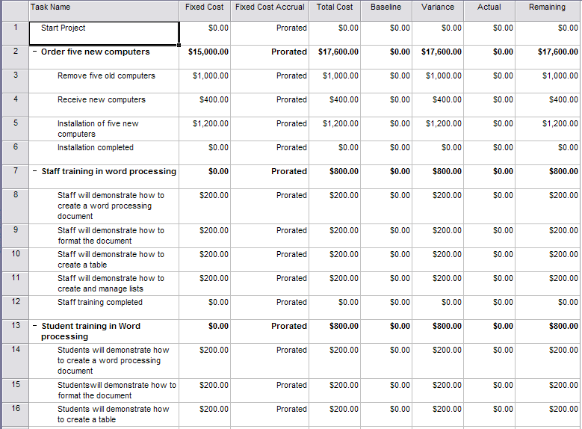

Budget Analysis Continued

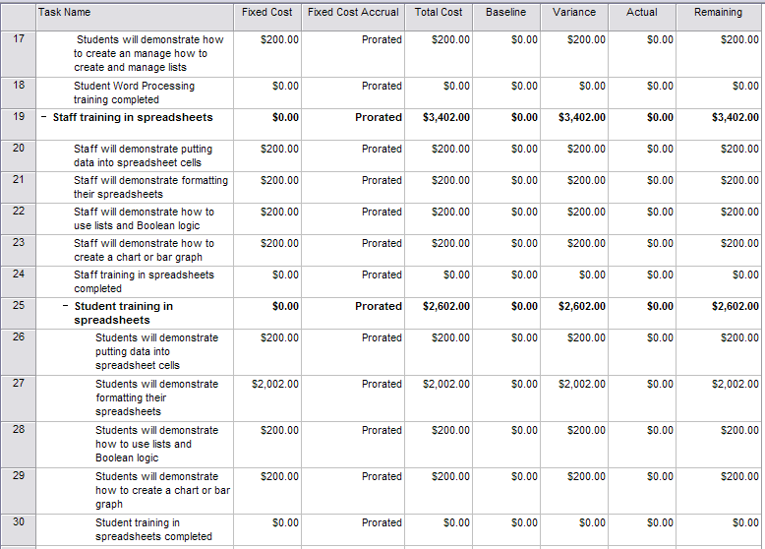

Budget Analysis Continued

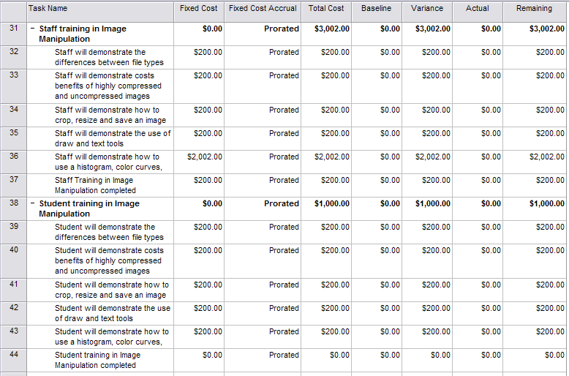

Task Name – Start Date – Finish Date

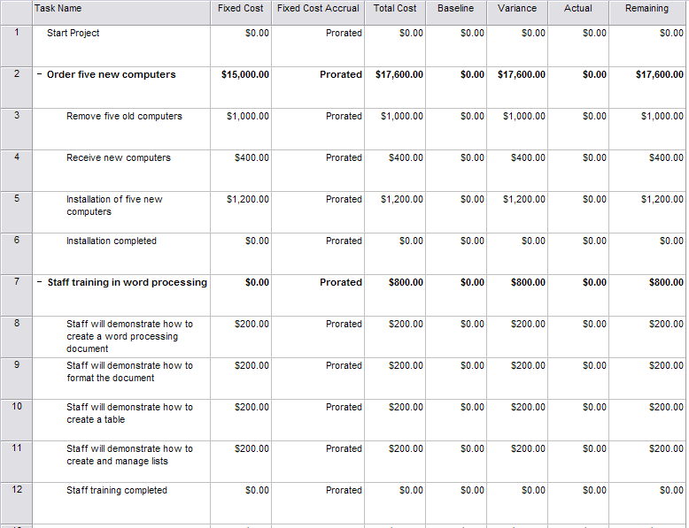

Task Name – Start Date – Finish Date Continued ……………..

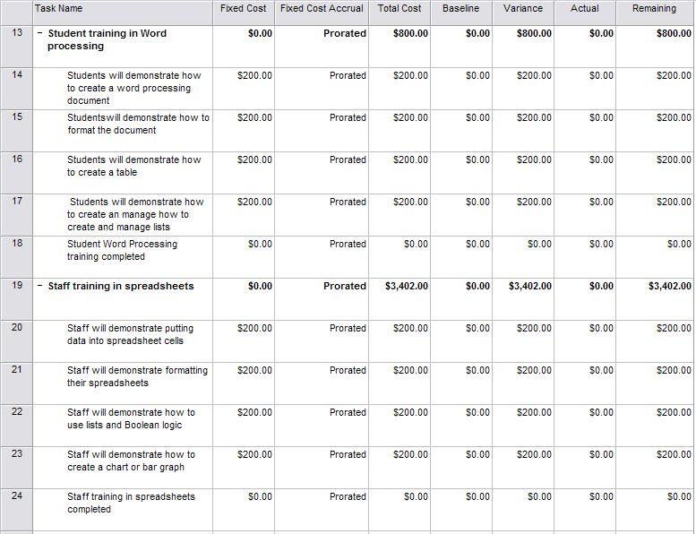

Task Name – Start Date – Finish Date Continued ……………..

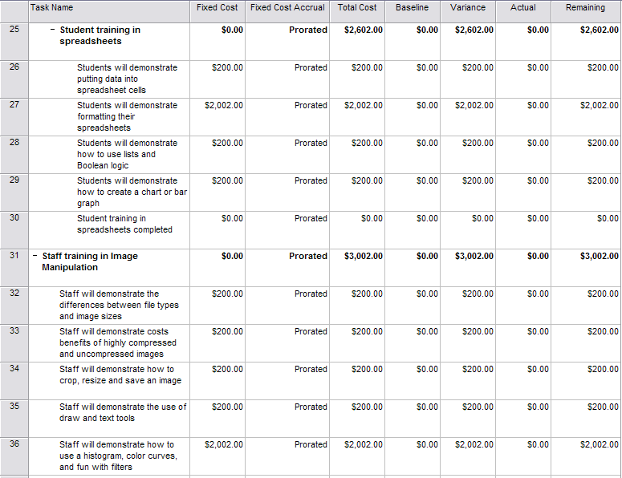

Task Name – Start Date – Finish Date Continued ……………..

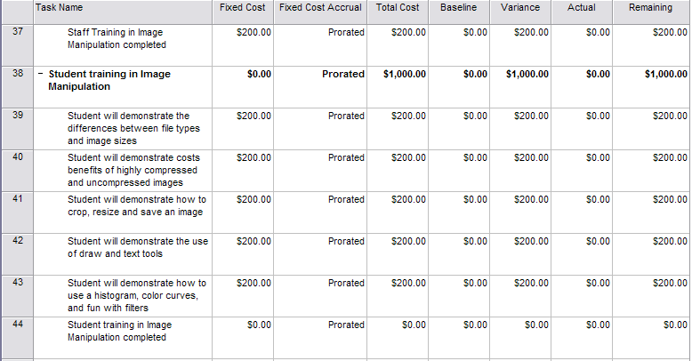

Summary of Start – Finish
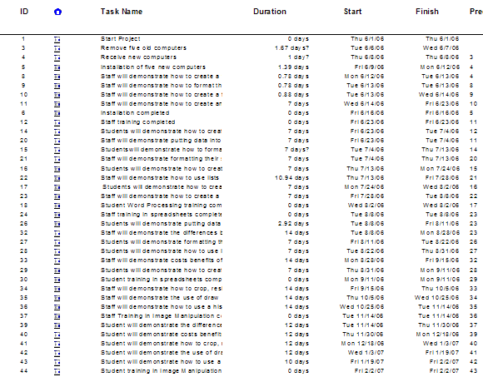

Milestones
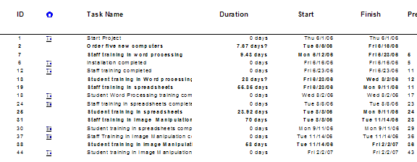

GRANT PROPOSAL INFORMATION
Possible computer grant monies:

Corporate Giving -- Details: Dell Computer
In the United States, Dell awards a variety of grants, including Healthy ... grants that aim to address technology access needs through computer labs in ...
www.businessweek.com/investing/ philanthropy/2005/companies/DELL.htm - 11k -

Technology Grant News Technology Grants
America Online and Dell will give 5000 low-income students a free refurbished personal computer and a year's worth of Internet access. ...
www.technologygrantnews.com/page-8.html - 31k - Cached - Similar pages

Bill Gates Announces Microsoft Grants to Support Technology ...
Our goal with today's grants is to create a technology experience for ... "I want to thank Michael Dell and Dell Computer Corp. for joining with us to ...
www.microsoft.com/presspass/ press/2001/jul01/07-09southfladonationpr.mspx - 13k –

NIFL-WOMENLIT 2001: [NIFL-WOMENLIT:1358] Re: Dell and technolog
February 2000, Girstart received a 20000 dollar grant from the Dell Corporate ... curriculum aimed at teaching girls about computers and technology. ...
www.nifl.gov/nifl-womenlit/2001/0242.html - 11k -

eSchool News online - Grant Awards
Through this grant program, each of the institutions will receive six Dell Dimension computers. The recipients were selected based on their need for new ...
www.eschoolnews.com/news/showstory.cfm?ArticleID=1315 - 30k - Cached - Similar pages

GRANT OPPORTUNITY

Dell Foundation Equipping Youth
Connected Communities Grant Application 2006
- Please fill out this application in its entirety; incomplete applications will not be accepted.
- Qualifying applicants must be located in one of the following counties:
- In North Carolina: Forsyth County and Guilford County
- In Oklahoma: Oklahoma County
- In Tennessee: Wilson County and Davidson County
- In Texas: Travis County and Williamson County
- Please email completed application (word doc) to dell_foundation@dell.com
- We are unable to process applications sent via USPS.

Deadline for receipt of Connected Community Grant applications: July 14, 2006
Applications of more than 10 total pages will not be favorably reviewed

Organization Information

Date of Application: _ _________________________

Organization: ________________________________

Executive Director Name:
Email Address:
Phone:
Grant Coordinator Name:
Email Address:
Phone:
Communications/PR Name:
Email Address:
Phone:
Volunteer Coordinator:
Email Address:
Phone:

Organization Mailing Address: ___________________________

City, State, Zip code: ____________________________________

Main Phone: ___________________________

Main Fax: ___________________________

Organization Website address: _________________

County and State of Organization Residence: _______________

Tax Exempt #: ______________________________

Is your organization an IRS 501(c)3? Yes__ No __ (If no, then you do not qualify for a grant)

Organization Information (continued)

Have you received a Dell Foundation grant before? _____________

If yes, when/grant amount: _____________________________________________

Date organization was founded: ____________

Organization Mission:

Primary Programs/Activities:

Geographic Scope: ________________________

Profile/demographics of the targeted population served by the organization: __________________

Number of individuals served per year by the organization: ____________________

Number of children served per year by the organization: ______________________

Number of paid staff members: ___________________

List of Board Members (name and affiliation only):
(Please place a * next to all Dell Employees)

List of Dell employees who have contributed significant voluntary time to your organization in the past two years.
Financial Information

Current Total Annual Operating Budget:
Revenues (from all sources): $_________________
Expenses: $_________________
(Dell Foundation funds cannot exceed 20 percent of your annual operating budget)

Percentage of Expenses for Programs: _____%

Percentage of Expenses for Administration: _____%

Percentage of Expenses for Fundraising: ______%
(Must total 100% based on most recent audited year)

Program Information Specific to this Grant Request

Name of Program/ Project: ______________________________________________

Description of specific program for which you are requesting funding. Clearly identify specific community needs.

Profile of targeted population and geographic area served by this specific program.

Number of individuals served per year by this specific program: ________________

Number of children per year who will directly benefit from this program: _________

Is this a grant for a new program or continued program? ___________________

Program continuation or implementation date: _____________________

State the specific goals set for the program during the proposed grant period.
Indicate how your organization will positively impact participants/clients and the community needs described above. Bulleted list is acceptable.

Program Information Specific to this Grant Request (continued)

Clearly identify the program’s projected outcomes and what you anticipate being able to achieve with this grant. (Provide a bulleted listing of projected outcomes that include specific numbers).

How will you measure the impact of the program? Cite specific indicators of change you will track and how often. Include description of how you will collect and report data.

Provide a timeline of the proposed project plan; include major strategies/milestones:

Why is your organization the most qualified to meet this community need?

Name, title and relevant experience and expertise of key program staff:

Is this specific program a partnership with other non-profits? _____________________

If yes, list non-profit partners:

Program Information Specific to this Grant Request (continued)

Is this program a pilot program? __________

Was this a pilot program which has been replicated elsewhere? ____________

If this is not a new program, what challenges have been faced in the past, and how were these challenges addressed?

Total program cost: $____________________

Program Budget by line item, indicating items to be covered by Dell Foundation funding:
Expense Item Total Budget Cost To be Funded by Dell Foundation
______________________ __________________ ___________________

______________________ __________________ ___________________

______________________ __________________ ___________________

______________________ __________________ ___________________

______________________ __________________ ___________________

List other funders for this specific program and indicate if funding commitments have been secured or are pending:

How will you sustain this program after Dell Foundation funding ends?

Please outline your proposed acknowledgement of Dell Foundation support

Email this application to: dell_foundation@dell.com

Thank you for submitting your proposal. You will receive an auto-reply from The Dell Foundation mailbox.
We will send notification of the grant on or before August 28, 2006.

