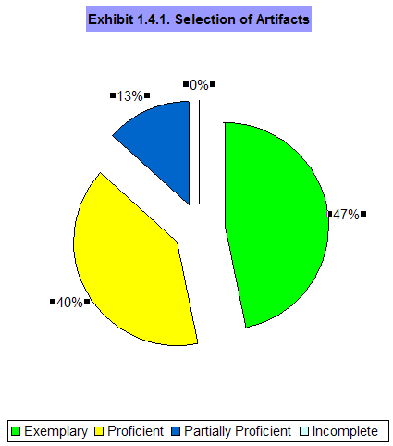

MIT 531

Dr Abdou Ndoye

Assessment of Learning

Marolyn A. Schauss

2007



Table of Contents

Section I: Proposal 3
Section II: Learning Outcomes / Objectives 5
Section III – Assessment Strategies 10

Section IV: Assessment Instruments 15
- Example 1.1. ……………………………………………………………………………..20
Observation rubric for oral presentation per learner, per Learner Objective. 20
- Example 1.4. (Rubric is almost identical to example 1.1
Summative Rubric for MSWord version XP applications Learning Outcome 1.4. 22

Section V: Use of Data 26
- Exhibit 1.4- 1 through Exhibit 1.4- 8……………………………………………………………...………….33

Appendix A 36
Appendix B 37
Appendix C 38
Appendix D 39

Section I: Proposal

Introduction for Applying Learning Outcomes

Through the Instruction of
Microsoft Word

Christian Women's Job Corps (CWJC) of Wilmington, North Carolina is a division of a national CWJC organization founded in 1888, maintaining a membership of approximately one million, and providing knowledge for employment opportunities through curriculum areas of study to include life skills and job readiness for women. Teaching the proficiencies of Microsoft (MS) Office Word XP applications within an assigned schedule provides women with the necessary skills to help attain employment or enhance the present employment opportunity.
The learning components include introductory concepts for Microsoft Word. The most frequently applied strategy for instruction is to learn by example wherein each learner is provided a hard copy of detailed, pictorial instructions for each required Microsoft application. The applications include how to construct an informal business letter, how to save a document using the MS Word SaveAs command, the development of a collage using MS Word WordArt, and real-life performance applications of promotional hand-out materials The purpose of the assessment is to help provide information in order to enhance employment opportunities. The assessments will help answer the following questions:
- Is learning happening as the instruction is occurring?
- What was learned at the end of the instruction?
Standards for the instructor and instructional materials must comply with the CWJC organizational goals to include the respect, autonomy and uniqueness of each individual learner. Other values include nurturing the giftedness of women and accepting the responsibility to help them use their gifts. The instructor must also act in accordance with the standards to submit to the local board purchases for developmental materials or equipment deemed necessary for higher-educational outcomes.
The instructions for Microsoft Word will each be learner centered through applying real-world applications. The environment will be of a professional setting wherein the learner’s concepts and achievements are respected and constructively evaluated. The purpose of the assessment is to: set goals for improvement; determine the levels of proficiency; determine if the learner is making progress; and select specific teaching strategies to meet the goals for instructional decision making. Multiple measures are embedded within the course material to assess learner comprehension of lesson plans. Types of assessment evaluations include formative (monitoring the progress of each learner and revising assignment accordingly), diagnostic (identifying the causes of ‘stumbling blocks’) and summative (determining end-of-course achievement).
According to the American Association for Higher Education (AAHE) assessment should employ a diverse array of methods, including actual performance to reveal change, growth and increasing degrees of integration. MS Word instruction is performance (criteria) based tied back to the CWJC goals for the purpose of empowering the learner through curriculum study the actual ‘doing’ as opposed to the ability of ‘knowing’. The multidimensional performance outcomes directly equate to the learner’s real-life experiences as being valued by the process as well as the product. Rubric assessment for measurement will monitor a series of activities and growth over a period of time for the goals of continuous improvement.

Section II: Learning Outcomes

The course is a performance based module for learners to become proficient with Microsoft Word, version XP for the purpose: of either enhancing the learner’s present employment position or exhibiting skills to seek new employment. The performance based objectives specifications are a list of criteria the learner must meet to complete the assignment. The criterion is embedded in each Learning Outcome. The performance objectives will clearly communicate the instructional goals. The meta-cognitive performance skills help to determine growth and development of the learner. Each learner is provided a computer and the necessary job aids to complete the learning outcomes. Based on the following objectives the learning outcomes are parallel in the matrix:

  - 1.1. Demonstrate fundamental knowledge of MS Word.
  - 1.2. Relate real-life MS Word applications for professional or personal use.
  - 1.3. Develop an informal business letter.
  - 1.4. Apply MS Word techniques to create promotional hand-outs.

Objective | Learning Outcome | Instructional Strategies /Techniques | Rationale - based on Gagne’s Taxonomy
1.1. The learner will be able to demonstrate fundamental knowledge of MS Word. | 1.1 Given a detailed job aid the learner will demonstrate how to save a MS Word document on the learner’s computer Desktop by using the Microsoft Word SaveAs command. | The instructor will provide each learner with a job aid for saving a document in MS Word.  The instruction is designed to step-by-step inform the learner of the purpose for the instruction.  The instruction is designed to establish criteria for assessing learner performance.  The learner is given a job aid with eight steps to follow in order to demonstrate the SaveAs command.  The learner will combine the knowledge of the eight step rules and demonstrate a completed SaveAs command. | Demonstrate is an Intellectual Skill, a Rule of Higher Order making use of step-by-step MS techniques to guide the learning.
Objective | Learning Outcome | Instructional Strategies /Techniques | Rationale - based on Gagne’s Taxonomy
1.2. The learner will relate ‘real-life’ MS Word applications for professional or personal use. | 1.2 Given a current magazine, selected by the learner, and a job aid, the learner will create a computerized replication of the cover of the magazine within one class using MS Word applications. | The instructor will provide the learner with several magazines allowing the learner to choose a magazine cover of interest.  Following, the learner is asked by the instructor to replicate the cover using MS Word applications.  The Intellectual skills from the learner required for replication will allow for immediate feedback from the instructor encouraging continued independent practice of the applications.  Choosing to make use of a variety of applications indicates a measurable assessment of learner proficiency and knowledge of MS Word tools. | Create is an Intellectual skill of Discrimination between the different features of MS Word applications.  The learner will have to remember and implement the correct application in order to complete the replication.  Creating a replication of nationally read magazine covers will drive the learner to ‘real life’ performance.  Another reason for selecting the replication assignment is because the results are measurable and easily assessed for learner MS skills.
Objective | Learning Outcome | Instructional Strategies /Techniques | Rationale - based on Gagne’s Taxonomy
1.3. The learner will demonstrate how to develop an informal business letter. | 1.3 Given a print example of an informal business letter the learner will generate a personalized informal business letter of appropriate structure for an informal business letter complying with MS Word applications.. | The instructor will allow the learner to personalize their own informal business letter content and salutation to enhance retention and transfer of knowledge.  The learner is required to produce a format equal to, but not in duplication of, the job aid example.  An entire one class time-frame is provided the learner to develop a letter; therefore the instructor has time to provide guidance and cues whenever necessary and assess the independent performance by observation and finished product. | Generate is an Intellectual Skill of Higher Order Rules.  The learner will apply a new combination of rules to solve a complex problem of generating an informal business letter.
Objective | Learning Outcome | Instructional Strategies /Techniques | Rationale - based on Gagne’s Taxonomy
1.4. The learner will demonstrate how to apply MS Word techniques to create promotional hand-outs. | Given a job aid of MS WordArt the learner will apply five techniques of MS WordArt for the purpose of creating a promotional hand-out. | The learner will be informed of every detail required of the learner to reach performance.  Minimal learner feedback will be a vital part of the instructional assessment. The learner will be allowed to use their imagination in a collage effort to demonstrate knowledge and skills retained from previous instruction.  The learner performance will be used to evaluate: independent study versus group participation; knowledge of application retrieval; organization and chunking skills; accuracy and clarity and value of instructional materials. | Apply is an Intellectual Skill of Higher Order Rules.  The learner will be required to apply a combination of rules to solve the problem of creating a promotional hand-out.

Section III – Assessment Strategies
MIT 531 Marolyn A. Schauss

Learning Outcomes | Instructional Strategies | Assessment  Type & Technique  Direct or indirect  Criterion or norm | Rationale
1.1. Given a detailed job aid the learner will demonstrate how to save a MS Word document on the learner’s computer Desktop by using the Microsoft Word SaveAs command. (Please refer to Appendix A).  . | The instructor will provide each learner with a job aid for saving a document in MS Word.  The instruction is designed to step-by-step inform the learner of the purpose for the instruction.  The instruction is designed to establish Criterion for assessing learner performance.  Discovering important characteristics such as learner understanding and completion of an assignment, and respecting the variability from learner to learner are identified for assessment. | The strategy is criterion based on learner accomplishment and not compared to other learners.  The assessment will use direct measures providing evidence of learner mastery of the objective.  The strategy is designed to assess a learners reading, interpretive and following instruction skills.  Course Activity – the learner will save a MS Word document by using the SaveAs command on the learner’s computer Desktop. | Though there are many strategies to achieve most applications in MS, there is only one strategy to accomplish a ‘SaveAs’ document on the Windows Desktop using MS Word.  The strategy is directly aligned with the objective learning of how to SaveAs a document using MS Word.
Learning Outcomes | Instructional Strategies | Assessment  Type & Technique  Direct or indirect  Criterion or norm | Rationale
1.2 Given a current magazine, selected by the learner, and a job aid, the learner will create a computerized replication of the cover of the magazine within one class using MS Word applications (Please refer to Appendix B). | The instructor will provide the learner with several magazines allowing the learner to choose a magazine cover of interest.  Following, the learner is asked by the instructor to replicate the cover using MS Word applications.  The intellectual skills for replication will allow for immediate feedback from the instructor encouraging continued independent practice of the applications.  Choosing to make use of a variety of applications indicates a measurable assessment of learner proficiency and knowledge of MS Word tools. | The strategy is criterion based on learner accomplishment and not compared to other learners as with norm assessment.  The performance is of direct assessment providing evidence of choices made by the learner as to selection of applications from the task bar to master completion of the assignment. The assignment is direct in so much as no matter who has the assignment; the final product is to replicate a chosen magazine cover. There is no negotiation as to what tools to use to complete the product.  The validity will depend on the accuracy of replication.  Step 1: The learner will choose a magazine cover of preference.  Step 2: The learner is given a job aid (Appendix B) as a reference point of the so chosen. The job aid will have all the necessary cues for completing the instruction.  Step 3: The learner will replicate a magazine cover by choosing several, or all of the following MS applications and the companion application drop-down window for implementation: Edit; View; Insert; Format; Tools; Table; Window; Help. | Magazine covers are generally created by professionals having been in the field of design for many years.  Encouraging a learner to tackle the challenges of replication, and having the challenge met is the basis for understanding and transferring knowledge in the world of MS Word.
Learning Outcomes | Instructional Strategies | Assessment  Type & Technique  Direct or indirect  Criterion or norm | Rationale
1.3 Given a print example of an informal business letter the learner will generate a personalized informal business letter of appropriate structure for an informal business letter complying with MS Word applications (Please refer to Appendix C). | The instructor will allow the learner to personalize their own informal business letter content and salutation to enhance retention and transfer of knowledge.  The learner is required to produce a format equal to, but not in duplication of, the job aid example.  An entire one class time-frame is provided the learner to develop a letter; therefore the instructor has time to provide guidance and cues whenever necessary and assess the independent performance by observation and finished product. | The strategy is criterion based on learner accomplishment and not compared to other learners.  The application is of direct assessment providing evidence of format compliance made by the learner as to selection of applications from the task bar to master completion of the assignment.  The assignment is direct in so much as no matter who has the assignment; the final product of format is to comply with professional standards provided through MS. There is no negotiation as to what tools to use to complete the basic structure of an informal business letter.  Step 1: The learner is given a job aid to begin concentration on informal business letters. (Appendix C).  Step 2: The learner is guided through the job aid as the instructions are verbally presented by the instructor.  Step 3: The learner will be expected to comply with the basic format.  Step 4: The learner will be encouraged to use a friend, or family member, or whomever to address the letter.  Step 5: The learner is encouraged to supply the content of ‘real life’ interest.  Step 6: he learner is asked to remember the task bar applications and begin the assignment. | The basic assignment of following formal letter instructions maintains confidence from the learner of the course of action to receive the knowledge.  The choice of content matter and the personalized salutation for the learner maintains enthusiasm for the project and expands the cognitive skills.  There is no negotiation with the structure of the informal business letter. The learner is encouraged ‘set’ all features of the letter before beginning the content area.  The rationale for beginning the structure with a personal contact and ending with a personal contact is to provide continuous non-verbal feedback of interest with the project while embedding a structured format.
Learning Outcomes | Instructional Strategies | Assessment  Type & Technique  Direct or indirect  Criterion or norm | Rationale
1.4. Given a job aid of MS WordArt the learner will apply five techniques of MS WordArt for the purpose of creating a promotional hand-out (Please refer to Appendix D). | The learner will be informed of every detail required of the learner to reach performance.  Minimal learner feedback will be a vital part of the instructional assessment. The learner will be allowed to use their imagination in a collage effort to demonstrate knowledge and skills retained from previous instruction.  The learner performance will be used to evaluate: independent study versus group participation; knowledge of application retrieval; organization and chunking skills; accuracy and clarity and value of instructional materials. | The strategy is criterion based on learner accomplishment and not compared to other learners.  The application is of direct assessment providing evidence of compliance made by the learner as to the selection of applications from the MS task bar to master completion of the assignment.  The assignment is direct in so much as no matter who has the assignment; the final product must comply with the process of selection for the combination of the correct tools. There is no negotiation as to what tools to use to complete the task.  Step 1: The learner is introduced to MS WordArt and briefed as what to expect in the given material. The learner is introduced by the instructor to MS WordArt as an enhancement to other task bar applications  Step 2: The learner is handed a print job aid (Appendix D) of MS WordArt and the paper is individually read aloud, in unison, by each learner.  Step 3: After each page is verbalized the learner is asked to perform the tasks(s). Following is the viewing and reading and implementation of the second page, and so forth.  Step 4: The learner is verbally provided two days in which to complete the assignment.  Step 5: Pre-assessment of the knowledge of the MS tools by asking the learner for a verbal response, (example: learner, please use your job aid and verbally share with the class how to open WordArt.  Step 6: The learner is informed the second day their finished collage will be presented publicly to friends and family, directors and advisory boards attending a banquet in their honor. | MS WordArt requires higher levels of processing information from the learner. Organization, rationale, compliance, structure, is but a few of the many cognitive skills which must be applied to complete a collage.  A provided collage is completely different from the learner begin required to create a collage from their own creativity and real-life experiences. The instructor is able to observe the readiness of a learner with learner thought processing and physical application.  The learner performance also indicates patterns of creativity, i.e. overuse of appreciation for lines, dots, color.  No matter the collage, the applications will be identical for each learner. Where to locate the desired tool, how to apply the tool, how to manipulate the tool.  Allowing two days gives the learner the opportunity to come back the second day with new ideas for completion.  Informing the learner of a public presentation of their completed word and the opportunity to express why they chose the expression, helps to instill performance of group participation.

Section IV: Assessment Instruments

Assessment instruments for teaching Microsoft Word applications will be explained in the following format:

- for WHOM is the instrument directed;
- WHAT will the instrument include;
- WHERE will the instrument be performed;
- WHEN will the instrument begin and conclude;
- HOW is the instrument to proceed (refer to the included Example 1.1. and Example 1.4. of this document); and
- WHY the instrument is developed.

- Other features will include: (a) identifying possible THREATS to the validity and reliability of the assessment instruments; (b) addressing and correcting the THREATS to the validity and reliability of the assessment instruments.

- PORTFOLIO development

WHO:
The following assessment instruments are developed for learners to parallel the overall CWJC goal of providing knowledge for employment opportunities through curriculum areas of study to include life skills and job readiness for women.

WHERE: WHEN:
The learners are informed at the beginning of a class session there will be interim class opportunities to display and orally describe their work to management. The learners are also informed, at the end of the course there will be a banquet in their honor wherein the learner is expected to present their portfolio of accomplishments, in notebook and PowerPoint presentation form, and to orally describe why they have chosen a particular format or design.

WHAT:
The following four criteria were agreed upon by the learners as being important to their learning: (a) content, (b) organization, (c) delivery, and (d) verbal communication. The criterion to develop a rubric is for the purpose of evaluating the on-going levels of accomplishment as well as end of course performance.
(a) The content will consider the construct, the individual characteristics (skills, accomplishments, abilities, traits and qualities) of the assessment. The validation of the construct will determine the extent of performance from the learner in efforts to eliminate under-representation or irrelevant variances of unfairness. Analyzing pre-test results and accumulating various types of learner evidence, e.g. learning disabilities, followed by revision of material will help to confirm construct validation. Construct validation includes:
  - Specifications are well defined
  - Learners have the opportunity to orally explain their responses
  - Differences in applications are compared to former learners’ results. The differences are compared before instruction and after instruction
  - Learners are provided with results of pre and post tests to help develop a realistic understanding of their strengths and weaknesses contributing to improved learning and positive self-image.
(b) The organization of content allows for comparison of learning outcomes to assure the growth of highly developed skills and real-life correlations.
(c) The rubrics help to assess the development of the learner though delivery. The end of the course requirement for delivery includes a public verbal presentation of learner accomplishment and a portfolio of learner accumulated performance documents.
(d) Throughout the course, verbal communication is extremely important for learner and instructor understanding as to clarification of real-life applications selected by the learner.

HOW:
The rubrics are designed to keep the learner on-task and help to enforce the importance of quality and completion of their tasks. The rubric is a tool wherein learner expectations for performance are articulated in advance of beginning a project. The learner is expected to: demonstrate the absorption of transferred knowledge; understand the knowledge; and explain the application of specified knowledge. The rubrics help the learner become better judges of the quality of their own work through over time evaluations.

WHY:
The rubrics are developed for the purpose of formative assessment wherein the instructor will have time to provide feedback and constructively encourage the learning performance. Each learner will be given a copy of the rubrics to encourage performance development. The instructor will be the only source for assigning the grade or providing the comments for measurement.

Two rubrics are developed in advance of assignment and each measure is weighted equally, increasing the validity of the product.

THREATS:
(a) Identifying possible THREATS to the validity of the assessment instruments (where validity is a quality of the appropriateness of interpretation of the results rather than the assessment itself) include not making allowances for:
- equal attention to negative effects of performance as well as positive effects (example: provisions not being made for English language learners or learners having to leave school);
- consideration of learner contributions (example: overemphasis on drill and practice and other factual knowledge at the expense of conceptual understanding or problem-solving applications);
- the learner to exhibit unique motivational strategies (example: construct considerations such as test anxiety, test-taking skills);
- un-intended consequences (example: rubric scoring not relevant and representative of the achievement domain to be measured).

(b) Addressing and correcting possible THREATS to the validity of the assessment instruments include some of the following suggestions:
- create all assessments with appropriate and meaningful outcomes (example: assessment tasks must be relevant and representative of the domain of tasks about which interpretations of assessment results reflect important goals and objectives);
- make provisions for portfolio and oral presentations rather than designing assessments for rudimentary outcomes (example: assessments must make provision for construct validation of learner characteristics of skills, accomplishments, abilities, psychological traits and personal qualities);
- make certain the learner understands all vocabulary in the assessment and no aspect of the assessment is vague leaving uncertainties for the learner (example: during the development of the rubric the learners “think aloud” as the learners perform the tasks to ascertain understanding; construct the rubric to include variances of sentence structures);
- make certain the learners know how the results of the assessment will be used (example: clearly identify the domain of instructionally relevant learning tasks to be used to measure student achievement);
- make certain the learner believes the assessment is fair (example: the specifications describing the achievement domain to be measured, should be in harmony with what is taught; examine the items in each rubric and compare them to the specifications);
- allow adequate time to complete the assessment and provide the learner with expected time allocation (example: place the emphasis on the quality of work rather than how many performances were achieved in a given time-frame);
- concentrate on the quality of the interpretation rather than the results of the assessment (example: assessments need to reflect major learning outcomes i.e. problem-solving skills and complex thinking skills and synthesis of information rather than learner bottom-line score);
- Make certain the arrangement of assessment items are in congruence with the order of (example: less difficult to more difficult providing the learner with self confidence from achievement of the less difficult answers in the beginning of testing).
______________________________________________________________________________

(a) Identifying possible THREATS to the reliability (that state referring to the consistency of assessment results, obtaining similar scores when the same assessment procedure is used with the same students on two different occasions) of the assessment instruments include not making allowances for:
- consistency of measurement across raters, across tasks, and over time (example: consistency is always particular in type and is only reliable if the type is dictated by the use to be made of the results; therefore constancy of scores over time will provide future inferences whereas consistency of current understanding is measured in performance task to performance task);
- providing enough tasks to increase the reliability (increasing the size/number of tasks, increases the consistency of measurement) (example: a longer assessment will provide a more adequate sample of the behavior being measured, and the scores are apt to be less distorted by factors such as familiarity therefore increasing the consistency of measurement);
- Recognizing reliability is strictly a statistical concept (example: reliability refers to the results obtained with an assessment instrument and not to the instrument itself; reliable stability is an agreement between two sets of results from the same procedure).

b) Addressing and correcting possible THREATS to the reliability of the assessment instruments include some of the following suggestions:
- refer to the results obtained with an assessment (example: assessment results requires determining what is to be measured and then precisely defining tasks that require the intended knowledge, skills, understanding from the learner for reliability) ;
- recognize intervals between identical testing assessments attract outside characteristic influence challenging reliability (example: two forms of an assessment to the same group of learners in close succession provides a measure of learner generalization through equivalent methods; however over a long period of time, the outside influence, i.e. distractions, illness etc. measurement for reliability must construct versions of the assessment that are intended to cover the same domain of content and student skills then correlate the results). ;
- recognize test scores are not the complete accuracy of a learners understanding (example: a learner might score poorly on a supply type test but score highly on an essay test suggesting reliability of an assessment needs to be considered from many types of testing);
- hypothesize the assessment being given by other professors: (example: Would the test structure be the same? Would the grading be the same? Would the content be the same?)
- Recognizing maximum reliability is obtainable when the decisions to assessment tasks are (example: important; final; unalterable; verifiable; individual; and have lasting value).

PORTFOLIO:
Following are two examples of rubric assessments for observing oral presentations and portfolio development. The rubric information is given to the learner is advance of class instruction and developed with the learner for enhancement of material and criteria understanding over time.

The portfolio encourages the learner to become reflective of their work and to develop skills in evaluating the strengths and weaknesses of their work. The portfolio provides concrete examples of a learner’s development over time as well as current skills. The learner is provided opportunities to verbally explain why the examples were chosen for display. Because the focus is demonstrating growth and development of the MS Word tools, multiple versions of each MS Word application is necessary for a thorough and fair assessment.

Instructor feedback is necessary to keep the learner on-task and moving towards constructive development. The instructor will specify the purpose of the portfolio to the learner, provide guidelines for selecting portfolio entries, and specify the evaluation criteria. The instruction will not use the portfolio as a summative tool, rather, a targeted assessment of the over time growth /development of the learner.

The portfolio oral presentation will enlighten the audience as to: (a) the use of the portfolio; (b) who will have access to the portfolio; (c) why the learner felt the chosen applications were appropriate for their portfolio; (d) how the learner participated in constructing a rubric for assessing their growth and understanding of MS Word applications as apply to the learner objectives. The learner is also encouraged during oral presentation time to express what they think of their work and how their work might be improved.

Example 1.1.
- Observation rubric for oral presentation per learner, per Learner Objective.
- Observation rubric for portfolio assignment expectation per learner, per Learner Objective.

Oral presentation rubric: (Observable and measurable)  Learner # |  |  |  | Portfolio Performance rubric: (Observable and measurable)  Learner #
L. O. #1.1. Given a detailed job aid the learner will demonstrate how to save a MS Word document on the learner’s computer Desktop by using the Microsoft Word SaveAs command. | Above Proficient  (3) | Proficient  (2) | Below Proficient  (1) | L. O. #1.1. Given a detailed job aid the learner will demonstrate how to save a MS Word document on the learner’s computer Desktop by using the Microsoft Word SaveAs command. | Above Proficient  (3) | Proficient  (2) | Below Proficient  (1)
Delivery / presentation  (a) Audible  (b) Poise  (c) Illustration | All three indicators observed. | Two of the three indicators observed. | One or none of the indicators observed. | Understanding of assignment  (a) the document was saved using the correct order  (b) the document was saved in the correct location  (c) the learner referred to memory | All three indicators observed. | Two of the three indicators observed. | One or none of the indicators observed.
Content  (a) Accuracy  (b) Relevance  (c) Organization  (d) Progress from beginning to end | Three of the four indicators observed.  Indicator (a) must be included. | Two indicators observed. | One or none of the indicators observed. | Methods / development used in the assignment:  (a) Correct order  (b) Choice  (c) Hesitation  (d) Need of assistance  (e) Use of job aid  (f) Completion of task | Four of the six indicators observed. Indicator (f) must be included. | Three of the six indicators observed. Indicator (f) must be included. | One or two of the indicators observed. Indicator (f) must be included.
Language  (a) Vocabulary  (b) Enunciation  (c) Grammar | All three indicators observed. | Two of the three indicators observed. | One or none of indicators observed. | Growth/Development  (a) Display  (b) Compliance  (c) Achievement | All three indicators observed. | Two of the three indicators observed. | One or none of the indicators observed.
Physicality  (a) Body Movement  (b) Eye Contact  (c) Facial Expression | All three indicators observed | Two of the three indicators observed. | One or none of the indicators observed. | Language  (a) Vocabulary  (b) Grammar  (c) Sensibility | All three indicators observed | Two of the three indicators observed. | One or none of the indicators observed.
Real-life application  (a) Validity = content: (how relevant to the achievement domain/goals)  (b) Reliability = understanding of concept: (consistency)  (c) Usability = real-life parallel: (practicality) | All three indicators observed | Two of the three indicators observed. | One or none of the indicators observed. | Real-life application  (a) Validity = content: (how relevant to the achievement domain/goals)  (b) Reliability = understanding of concept: (consistency)  (c) Usability = real-life parallel: (practicality) | All three indicators observed | Two of the three indicators observed. | One or none of the indicators observed.

Summative Rubric for MSWord version XP applications Learning Outcome 1.4.

Points for observation of oral and portfolio communication per learner, per objective/outcome:

Partially Proficient, Incomplete, or an accumulation of less than 28 points indicates a need for the learner to repeat the course.
Learner Outcome | Exemplary | Proficient | Partially Proficient | Incomplete | Points
Selection of Artifacts | 9 points  All artifacts and work samples are clearly and directly related to the purpose of communication.  All components demonstrate the use of clear, well organized, and accurately presented communication. | 6 points  Most artifacts and work samples are related to the purpose of communication.  There are only one or two occurrences of unorganized, inaccurate, or difficult to interpret presented information. | 3 points  Few artifacts and work samples are related to the purpose of communication.  There are three or four occurrences of unorganized, inaccurate, or difficult to interpret presented information. | 0 points  Most artifacts and work samples are unrelated to the purpose of communication.  There are more than four instances of unorganized, inaccurate, or difficult to interpret presented information.
Reflections | 9 points  All reflections clearly identify and describe achievement of growth goals and include goals for continued learning.  All reflections illustrate the ability to effectively critique work and provide suggestions for constructive practical alternatives. | 6 points  Most of the reflections identify and describe growth goals for continued learning.  Most of the reflections illustrate the ability to effectively critique work and provide suggestions for constructive practical alternatives. | 3 points  A few reflections identify and describe growth goals for continued learning.  A few reflections illustrate the ability to effectively critique work and provide suggestions for constructive practical alternatives. | 0 points  No reflections identify and describe growth goals for continued learning.  No reflections illustrate the ability to effectively critique work or provide suggestions for constructive practical alternatives.
Use of Multimedia | 6 points  All the graphics, WordArt, creativity, enhance reflective statements and maintain interest.  Creativity of original ideas enhances the content for oral and portfolio communication in an innovative way. | 4 points  Most of the graphics, WordArt, creativity enhance reflective statements and maintain interest.  Most of the multimedia techniques indicate use of creativity and original ideas to enhance the content. | 2 points  A few of the graphics, WordArt, creativity enhance reflective statements and maintain interest.  Some of the multimedia techniques indicate original ideas and some evidence of enhancement for communication is expressed. | 0 points  The graphics, WordArt, and creativity are inappropriate and do not enhance reflective statements and are distracting from the overall presentation.  There is no use of creativity or original ideas evident to enhance the content of communication in any innovative way.
Captions | 3 points  Each artifact is accompanied by a caption that articulately explains the importance of that particular work including title, author, and date. | 2 points  Most of the artifacts are accompanied by a caption that articulately explains the importance of that particular work including title, author, and date. | 1 points  Some of the artifacts are accompanied by a caption that articulately explains the importance of that particular work including title, author, and date. | 0 points  None of the artifacts are accompanied by a caption that articulately explains the importance of that particular work including title, author, and date.
Ease of Navigation | 3 points  All the portfolio and oral communication sections (standards, artifacts, and reflections) connect back to the main table of contents. | 2 points  Most of the portfolio and oral communication sections (standards, artifacts, and reflections) connect back to the main table of contents. | 1 points  Some of the portfolio and oral communication sections (standards, artifacts, and reflections) connect back to the main idea of presentation. | 0 points  There are significant problems with the oral and portfolio communication sections (standards, artifacts, and reflections) connecting back to the main idea of presentation.
Layout and Text Elements | 3 points  The portfolio is easy to read. Fonts, point size, bullets, italics, bold, and indentations for headings and sub-headings enhance the presentation.  Horizontal and vertical white space is always used appropriately. Background colors enhance the readability and aesthetic quality of the text. | 2 points  The portfolio is generally easy to read. Fonts, point size, bullets, italics, bold, and indentations for headings and sub-headings enhance the presentation. A few minor format changes would enhance the presentation. Horizontal and vertical white space is used appropriately in most places. Background and colors generally enhance the readability of the text. | 1 points  The portfolio is often difficult to read. Fonts, point size, bullets, italics, bold, and indentations for headings and sub-headings do not always enhance the presentation. Some formatting tools are under or over-utilized. Horizontal and vertical white space is used inappropriately in some places. Background and colors are distracting in some places. Background colors diminish somewhat the readability of the text. | 0 points  The portfolio is difficult to read. Fonts, point size, bullets, italics, bold, and indentations for headings and sub-headings do not enhance the presentation. Many formatting tools are under or over-utilized. Horizontal and vertical white space is used inappropriately. The content appears cluttered. Background and colors are distracting. Background colors diminish the readability of the text.
Mechanics | 3 points  The presentation has no errors in grammar, capitalization, punctuation, and/or spelling. | 2 points  The presentation has a few errors in grammar, capitalization, punctuation, and/or spelling. Minor editing revisions are necessary. | 1 points  The presentation has four or more errors in grammar, capitalization, punctuation, and/or spelling requiring editing and revision. | 0 points  The presentation has more than six errors in grammar, capitalization, punctuation, and/or spelling. The presentation requires major editing and revision.
 |  |  |  | TOTAL POINTS | /36

The preceding Portfolio Rubrics are designed adopting: Joan Vandevelde rubrics © of 2003-2007 and Gearhart, Herman, Baker and Whittaker (1994).

Section V: Use of Data

Learning Outcome | Assessment | Assessment Tool | Data Collection Analysis | Method used for Data Collection /  and Justification for use
1.1 Given a detailed job aid the learner will demonstrate how to save a MS Word document on the learners’ computer Desktop by using the Microsoft Word SaveAs command (please refer to Appendix A). | The strategy is criterion based on learner performance.  The assessment will use direct measures providing evidence of learner mastery of the objective.  The strategy is designed to assess a learners reading, interpretive and following instruction skills.  The learner will add new knowledge to already learned knowledge of the MS Windows taskbar by demonstrating how to save a document by following the numerical order of the provided job aid.  Course Activity: – the learner will save a MS Word document by using the SaveAs command on the learners’ computer Desktop. | The validity of the observation tool is established from the four criterions agreed upon by the learners as being important to their learning (a) content, (b) organization, (c) delivery, and (d) verbal communication. (see section IV, WHAT for detailed validity information).  Reliability is in the form of statistical concept from the rubrics. (Please refer to Section IV, pg. 20 for rubric display).  The rubric provides enough tasks to increase the consistency of measurement as directly relating to the data collection.  Reliability is consistently measured from inter-raters, from tasks, and from over time.  The reliability of the rubric is pre-tested by the learner to assure every learner has the same guidelines. | The instructor will be looking for the learner’s knowledge of: (a) understanding of the assignment (b) the methods the learner will use to develop the assignment (c) compliance with MS command applications and job aid.  The learner is given a job aid with eight steps to follow in chronological order to demonstrate the SaveAs command on the learner’s Desktop making use of step-by-step MS techniques to guide the learning,  The learner will combine the knowledge of the eight step rules and demonstrate a completed SaveAs command.  (a) A qualitative rubric is designed to supply evidence the learning outcome has been met.  (b) The learners and the instructor and two inter-raters are the individuals providing the information for the rubric content and the data analysis.  (c) The qualitative information from the rubric dictates the method used for collecting the data.  (d) Triangulation between learner in-class performance, rubric assessments (before an analysis and after an analysis), and the development of a portfolio inserts, enhance the over-time validity of learner analysis.  The rubric instrument is precise enough to maintain consistency from inter-rater to inter-rater for analysis. The rubric is a construct confirming validity through combining several different indicators for measurement.  Quantitative information from the rubric will qualify the analysis for the purpose of learning through curriculum study. | The assessment method to collect the rubric data is through observation by the instructor, the manager, and an end-of-course public panel.  The data is provided by the learners with the guidance of the instructor.  The strengths of observation of rubric compliance are a direct assessment technique providing: (a) evidence of the learner mastery of the objectives (b) awareness of learner capability to follow instructional directions (c) awareness of learner capability to complete an assignment correctly (d) individuality to real-life situations through step #7 the Filename selection.  Weaknesses of the rubric include: (a) time to prepare the rubric (b) time to analyze the rubric (c) time to include inter-rater evaluation of rubric (d) protecting the learner confidentiality and privacy.  Observation is implemented by the instructor as being the most reliable and valid method for assessing learning outcome of #1.1..  The identification for #1.1 is ordinal The analysis is determined by hierarchy ranking for performance of the eight steps.  Principles for choosing the rubric data analysis method is based on the tasks (criterion) of what the learners can do. Once the data is collected, analysis will realize the medium (ranking) following the eight steps in numerical order, and the most frequently represented value (mode) of expected performance by the learner.  There are fifteen learners participating in the learner analysis. The following Excel grid is used to tabulate proficiencies and weaknesses of the learner indicating revisions of the MS Word SaveAs command presentation. The three statements in red indicate no performance by the learner.  Each of the following (Exhibits) were calculated per learner, per performance, per indicator for formative evaluation:

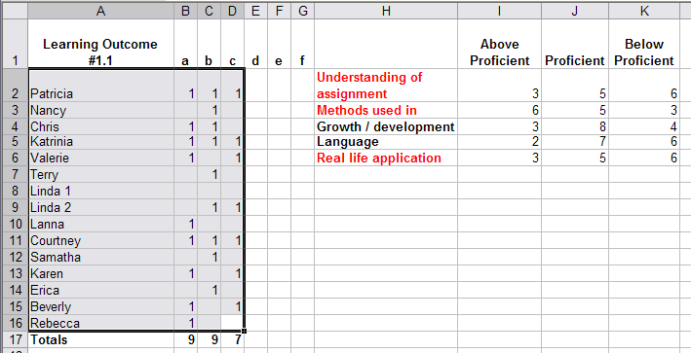

Following are five detailed graph assessments of five rubric statements
and indicator results created for learner knowledge enhancement:
Portfolio Performance Rubric: Observation tool
- the rubric is designed for learner by the learner and the instructor
- the rubric is assessed per statement by the instructor, the manager, the learners
- each statement has 3 or more indicators
- each indicator is formatively evaluated
- statement:
  - Understanding of assignment
Exhibit (A)
Indicators (a) needs attention

- Methods / Development used in the assignment
Exhibit (B)
Indicators (e) and (f) need attention

- Growth / Development
Exhibit (C)
Indicators (a) and (b) need attention

- Language
Exhibit (D)
Indicators (b) and (c) need attention

- Real-life Application
Exhibit (E)
Indicator (c) needs attention

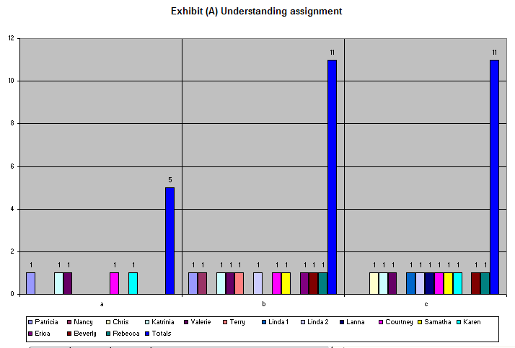

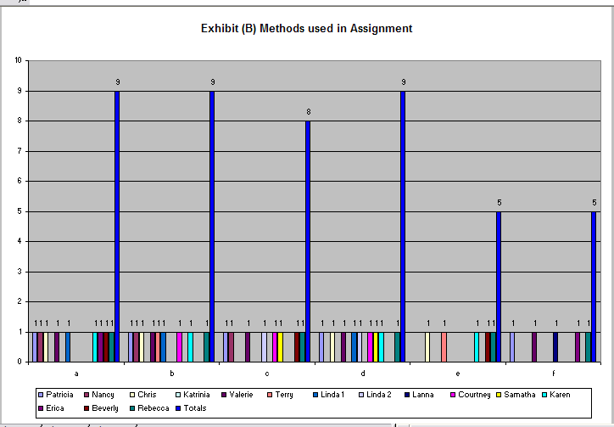
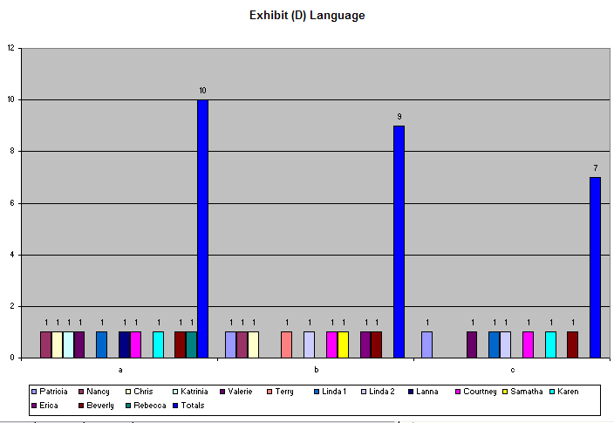
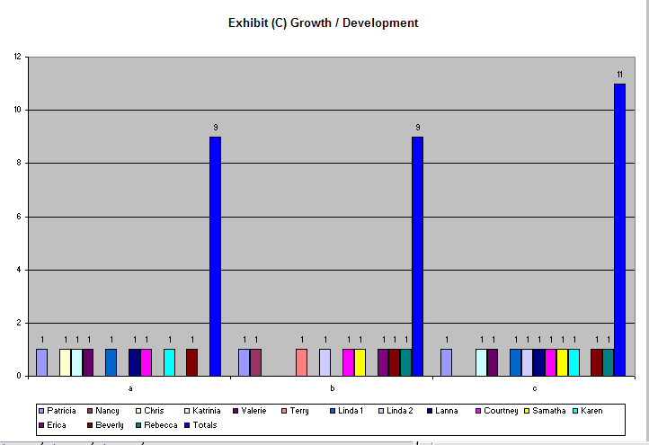

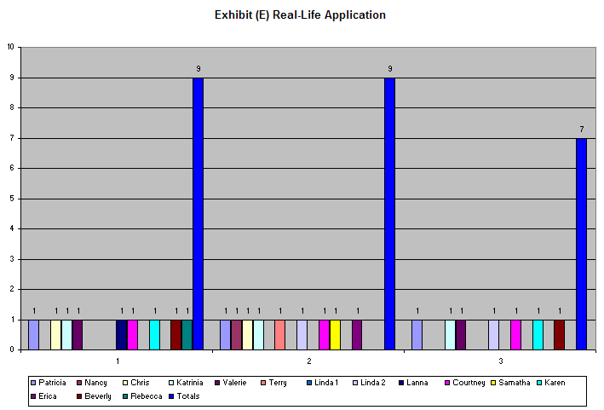
Learning Outcome | Assessment | Assessment Tool | Data Collection Analysis | Method used for Data Collection /  and Justification for use
1.4 Given a job aid of MS WordArt the learner will apply five techniques of MS WordArt for the purpose of creating a promotional hand-out. (Please refer to Appendix D). | The strategy is criterion based on learner accomplishment and understanding.  The assessment will use direct instruction for application and assignment for selection of applications from the MS Task bar and compliance with rules for selection of five techniques to create the product.  The strategy is designed to assess a learners reading, interpretive and following instruction skills.  The learner will add new knowledge to already learned knowledge of the MS Windows taskbar by applying the knowledge to create a promotional hand out.  Course Activity: – the learner will apply five MS techniques of WordArt to create a promotional hand-out. | The validity of the observation tool is established from the four criterions agreed upon by the learners as being important to their learning (a) content, (b) organization, (c) delivery, and (d) verbal communication. (see section IV, WHAT for detailed validity information).  Reliability is in the form of statistical concept from the rubrics. (Please refer to Section IV, pgs. 22-24 for rubric display).  The rubric provides enough tasks to increase the consistency of measurement as directly relating to the data collection.  The reliability of the rubric is pre-tested by the learner to assure every learner has the same guidelines.  Reliability is summative evaluated from the learners, the instructor and all the stakeholders. | The instructor will be looking for the learner’s knowledge of: (a) understanding of the assignment (b) the methods the learner will use to develop the assignment (c) compliance with MS command applications and job aid (d) selection of artifacts (e) reflections of the learner (f) use of multimedia with WordArt (g) captions being articulately explained (h) ease of navigation (i) layout and text elements and (j) mechanics of presentation.  The learner is given a job aid with complete MS WordArt instructions for application. The learner may choose to use the job aid or not when creating the promotional hand-out.  (a)The 1.4 summative rubric is qualitative and designed to supply evidence the learning outcome has been met.  (b) The learners and the instructor and the stake-holders are the individuals viewing and assessing the results of the summative rubric.  (c) The qualitative information from the rubric dictates the method used for collecting the data.  (d) Triangulation between learner in-class performance, rubric assessments (before an analysis and after an analysis), and the development of a portfolio inserts, enhance the over-time validity of learner analysis.  The rubric instrument is precise enough to maintain consistency from inter-rater to inter-rater for analysis. The rubric is a construct confirming validity through combining several different indicators for measurement.  Quantitative information from the rubric will qualify the analysis for the purpose of learning through curriculum study. | The assessment method to collect the rubric data is through observation by the instructor, the manager, and an end-of-course public panel.  The data is provided by the learners with the guidance of the instructor.  The strengths of observation of rubric compliance are a direct assessment technique providing: (a) evidence of the learner mastery of the objectives (b) awareness of learner capability to follow instructional directions (c) awareness of learner capability to complete an assignment correctly (d) individuality to real-life situations.  Weaknesses of the rubric include: (a) time to prepare the rubric (b) time to analyze the rubric (c) time to include stake-holder evaluation of rubric (d) protecting the learner confidentiality and privacy.  Observation is implemented by the instructor as being the most reliable and valid method for assessing learning outcome of #1.4..  The identification for #1.4 is nominal categorized in definition only. The arrangement of numbers is a substitute for nominal identification.  Principles for choosing the rubric data analysis method is based on the tasks (criterion) of what the learners can do. Once the data is collected, analysis will realize the percentage following the ratio of the most frequently represented value (mode) of expected performance by the learner.  There are fifteen learners participating in the learner analysis. The following Excel grid is used to tabulate proficiencies and weaknesses of the learner.  Each of the following (Exhibits) were calculated per learner, per performance, per indicator for summative evaluation to rank the percent of learners per percentile scoring.

- Following is an Excel table providing an example of how frequencies from fifteen learners were determined (Only frequencies for ‘Selection of Artifacts’ is displayed)
- The frequencies are displayed in pie chart percentage, ranking the assessment of learner outcome proficiencies per learner; per subject matter.

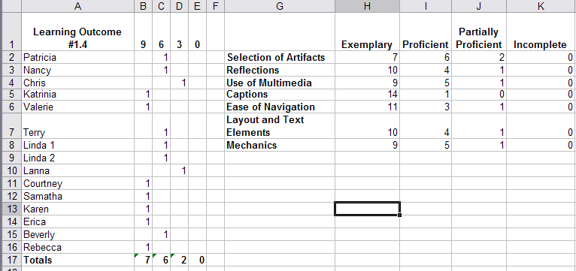

- Following are eight detailed pie-chart assessments of seven rubric statements.
- Frequency results are created for learner knowledge enhancement:

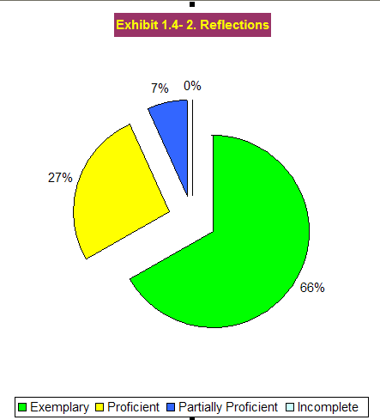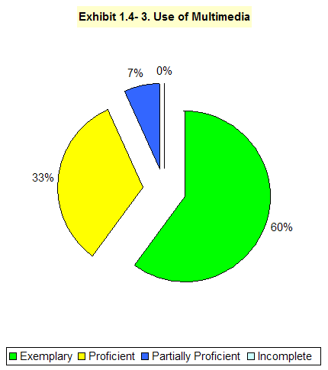

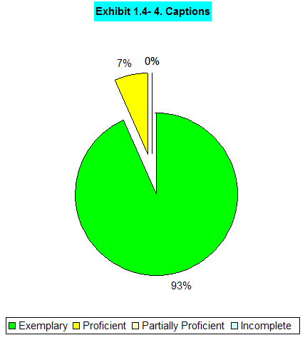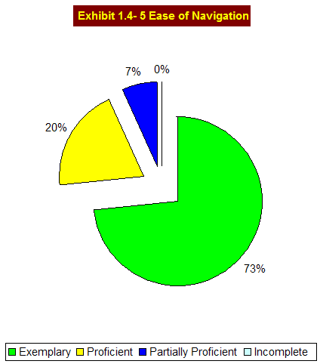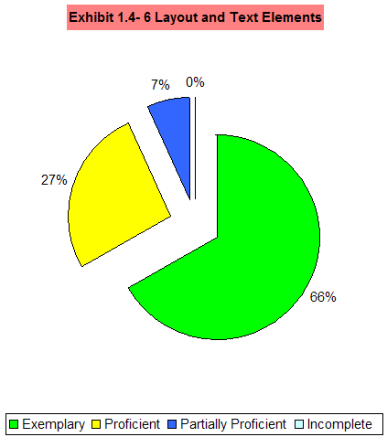

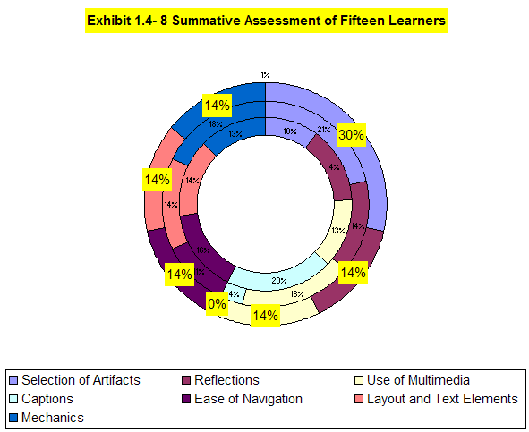

Appendix A
Saving a document using the MSWord SaveAs command

Learning how and where to save your documents:
- Click “File” on the task bar.
- Scroll down to “Save As”.
- When a new screen appears, look for the “down arrow” as shown for #3.
- Click the down arrow with a “left click “of the mouse.
- Scroll down to “Desktop” and “left click “the mouse once.
- Look to the bottom of the screen for “File Name”.
- Type in a name for your file.
- Click on the “Save” button at the right side of the “File Name” window.

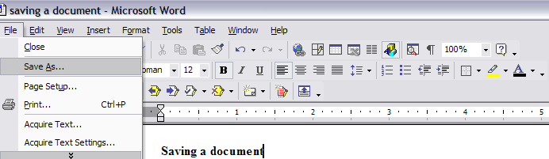
1.
2.

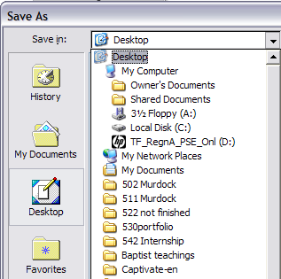
3.
4.
5.
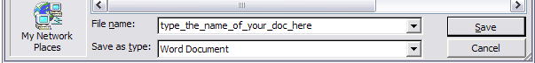
6.
7.
8.

© Marolyn Schauss 2007

Appendix B
Click the blue (words found on the MS task bar), then click the black word(s) in each box
VIEW / HEADER/FOOTER type your name / click page # / CLOSE
INSERT / REFERENCE ► CAPTION Figure 1 OK: INSERT / REFERENCE ► FOOTNOTE / INSERT
TABLE / INSERT ► TABLE: Choose 4 columns and 12 rows / OK
HIGHLIGHT the top four cells / TABLE/ MERGE CELLS
Create |  | Edit | Versions / FILE | Save / FILE
Preview / FILE |  | Print / FILE | Copy / EDIT | Cut / EDIT
Margins / FILE / PAGE SET UP |  | UNDO !!! / EDIT | Alignment / FORMAT/ Paragraph | Find/ Replace / EDIT
AutoFormat / TABLE |  | - Bullets  - FORMAT | Borders / FORMAT | Symbols / ☺ INSERT
Table/ TABLE / INSERT ►TABLE |  | Merge Cells / TABLE | Sort A-Z / Z-A TABLE | cHANGE case / FORMAT
Split Cells / |  | Convert / TABLE CONVERT ► TABLE TO TEXT Paragraph marks OK | VIEW / TOOLBARS √Standard  √ Format √ Drawing | Graphics  INSERT / PICTURE ► Clip Art (or) WordArt (or) …..
 | TABLE | Convert / TABLE CONVERT ► TABLE TO TEXT Paragraph marks OK | VIEW / TOOLBARS √Standard  √ Format √ Drawing | Graphics  INSERT / PICTURE ► Clip Art (or) WordArt (or) …..
Your Text Here |  |   Clip Art | Zoom / VIEW | - Numbering /  - FORMAT
Auto Spell / TOOLS / OPTIONS ► Spelling & Grammar |  | Header / Footer / VIEW / Header Footer | Fax / FILE / NEW/ New from template/ General Templates | Resume / FILE / NEW/ New from template/ General Templates / OTHER DOCUMENTS
Letter / FILE / NEW/ New from template/ General Templates |  | Memo / FILE / NEW/ New from template/ General Templates | Cut / EDIT | Paste / EDIT
Copy / EDIT |  | Background / FORMAT | Find / EDIT | Indents / FORMAT
Drop Cap / FORMAT  I am, you are, he is. |  | Text Direction / FORMAT | Word Count / TOOLS | START PROGRAMS ACCESSORIES PAINT
© Marolyn Schauss 2007

Appendix C
Instructions for writing an informal business letter:
Set Point Size: 12 … Set Font: Times New Roman … Center align
8x (Left Align)
The ‘x’ indicates the number of times to click the enter key. Click the Enter Key 8 x’s.

Click Center: Click Insert; Click Date and Time; Choose a format; Click OK.
4x (Left Align)

The ‘x’ indicates the number of times to click the enter key. Click the Enter Key 4 x’s.

Dear
The ‘x’ indicates the number of times to click the enter key. Click the Enter Key 2 x’s.

2x
CONGRATULATIONS! You have been nominated as the outstanding office employee of the month.
2x

The Committee, which made your selection, requires you submit a photograph of yourself to your supervisor in order that we may display your picture in the company’s executive offices.
2x

The XYZ Association is proud of your accomplishments. We look forward to honoring you at our ANNUAL AWARDS DINNER on December 4, 2007.
2x

Click Insert on the taskbar; Choose AutoText; Choose a closing from the Closing menu.
Click Enter key.
2x

James T. Manning, President
4x
The ‘x’ indicates the number of times to click the enter key. Click the Enter Key 4 x’s.

JTM/ (your initials in lower case) © Marolyn Schauss 2007

Appendix D
Learning to use Microsoft WordArt Page 1 of 4

- When clicking the “Insert…Picture…WordArt” or a button which looks like a tilted “” located at the bottom of the screen the following window will appear:

- Click one of the designs and then click “OK.”

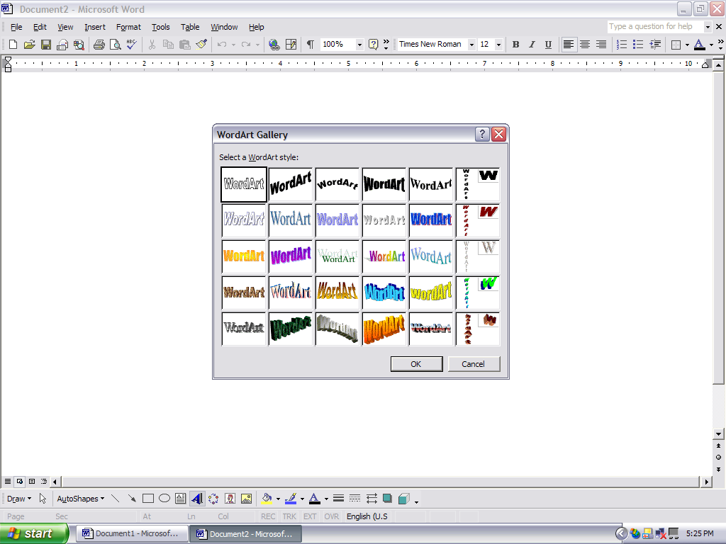

- You then will have a window looking like the following:

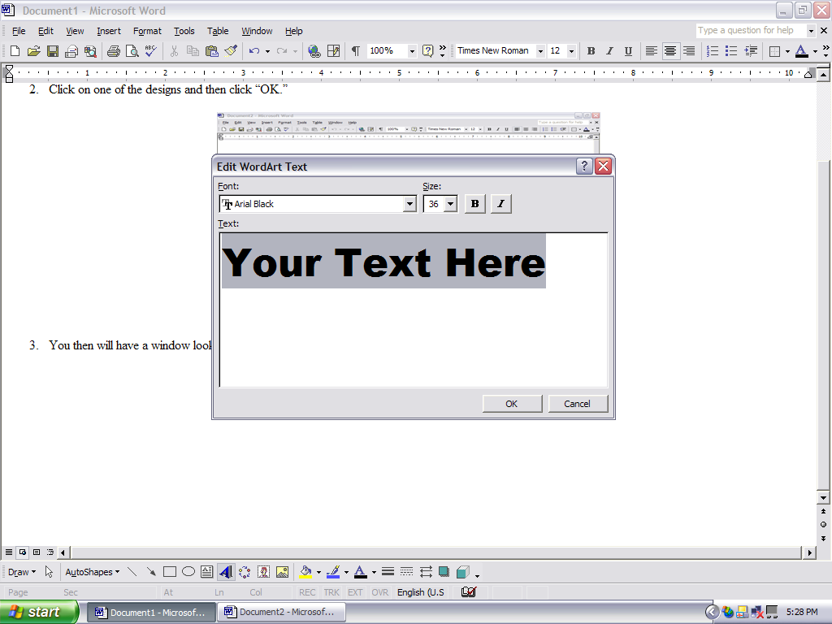

- Press the “Delete” key on your keyboard to get rid of the words “Your Text Here” and type your name; Press the “OK” button on your window.

Page 2 of 4 WordArt continued
- The following will appear: Click directly in the center of your name. You must now “Resize Your Name” to fit your paper by clicking and holding on one of the eight square boxes surrounding “Your Name.” When the double-headed arrow appears, click, hold, and drag to the size you desire.
Alfred Danials

- I want you to notice the little box which appears ONLY when you click the “Your Name” WordArt, and we will discuss one button at a time: Starting Left to Right with the little box on the “Tilted A”.

- I want you to notice the little box below “You Name” and we will take one button at a time: Starting Left to Right with the little box on the “Tilted A:

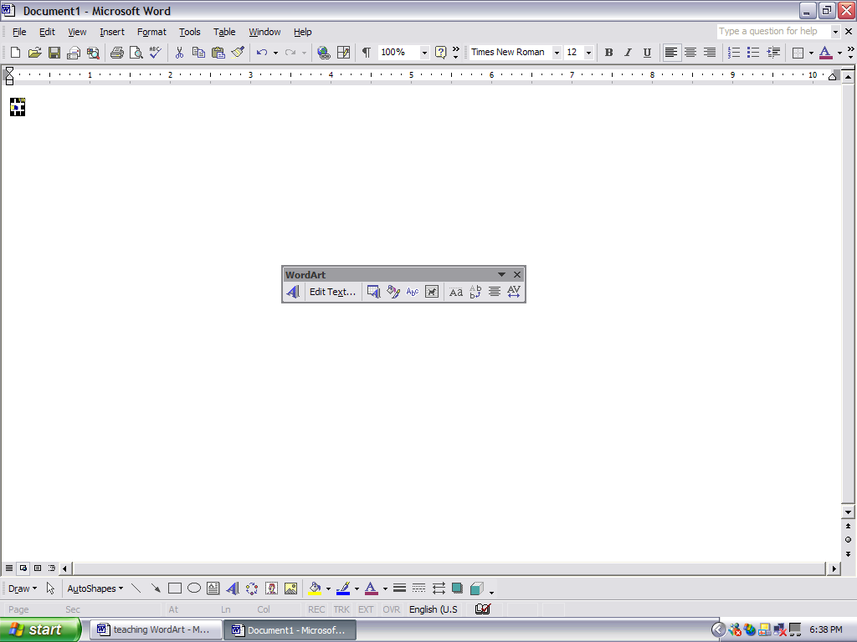
- The “A” gets you into Word Art.
- Once you have typed, the “Edit Text” allows you to easily change your typed text.
- The “A with what looks like a calendar around it” allows you to re-choose a design.
- The paint bucket allows you to:
  - Change the color of your words.
  - Change the color of your outline around the words.
  - Wrap the text around the Word Art.
- The “abc” gives you many options for changing the design of your words.
- The “3/4” circle allows you to rotate your design. Please do so now.
- The “Aa” allows you to go from upper case to lower; or lower to upper.
- The “Abb” will turn your text from horizontal position to a vertical position.
- The button with the lines will allow alignment.
- The last button is for Kerning or spacing between each letter of your WordArt
Page 3 of 4 WordArt continued
.
- Try each please. The following is “Very loose” as opposed to “Normal” as viewed below.
Look between the letters and you will see a lot of white space (known as air) in the first design,
Your Text Here

and very little white space between the letters in the second example.
Your Text Here

- Now I wish for you to place a shadow on your letters and experience several of the shadows to prove a point.

The Shadow keys are found on your monitor window for WordArt and look like little green boxes. To locate any of the following keys, please go to the following buttons:

VIEW
TOOLBARS
DRAWING

HAVE A GREAT TIME WITH WORDART AND BEGIN TO NOTICE ADVERTISING SIGNS
EVERYWHERE YOU GO….
Your Text Here
Page 4 of 4 WordArt continued

9. Creating WATERMARKS

- Click the following words typed in ‘blue’ found on the MSWord task bar
- INSERT
- PICTURE
- CLIP ART / or WORD ART / or AUTO SHAPES
  - Insert the Clip Art, WordArt, or Auto Shape
  - Then Activate the design by clicking in the middle of the design until all eight boxes are showing around the design

- FORMAT
- PICTURE
- PICTURE TAB
- Open the COLOR button and Click on the Washout or choose 90% transparency

- LAYOUT TAB or DRAW BUTTON found next to AutoShapes (probably bottom of screen)
- BEHIND TEXT
- OK

Now you are an expert and ready to practice by replicating or creating any print material.
Good Luck, I ‘m proud to learn with you!

© Marolyn Schauss 2007

Excel Session two
Publisher and PowerPoint sessions three and four

