

Created for New Hanover County Schools
August 2006

Acknowledgments

The manual is created for Karen B. Greene, Math/Science Instructional Services, New Hanover County Schools. The manual is created by Marolyn A. Schauss as part of the requirements for graduate course 542 Internship, summer session 2006 under the supervision of Karen B. Greene and Dr. Mahnaz Moallem, Professor MSIT, UNC-Wilmington.

Objectives

The objectives of the manual are to provide math and science teachers with complete instructions for opening and using the SAS environment. Each lesson is in compliance with state and national standards for grades k-12.

SAS is designed to provide the necessary tools to support teachers with classroom activities, innovative curriculum, research techniques, learner-centered measurable outcomes, and higher-order thinking skills.

The manual is designed to operate in conjunction with a computer. Place the manual next to the computer and begin following the directions. For brevity, the manual displays examples in Mathematics. Follow the same instruction for Science by choosing to click on the appropriate buttons for Science applications.

Should any technical problems occur contact your technology coordinator or telephone the SAS option at 1-888-760-2515.

Table of Contents

Acknowledgments 2
Objectives 3
Table of Contents 4
I. Teacher Login 5
II. Select 10
II. Selecting Subject Area 11
II. Selecting Course 12
II. Selecting Concept 13
III. Classify 14
III. Classify Available Resources 16
III. Classify Web Resources 19
III. Classify Classroom Activities 29
III. Classify Web Lessons 34
III. Classify Projects 39
III. Classify Project Launch 46
IV. Web 48
IV. Web Inquiry 50
IV. Web InterActivities 61
V. Launch Resource 70
VI. Student Login 84
VII. Assign Resources for Teachers 91

- Teacher Login

- How to get on-line with SAS

- Teacher Login

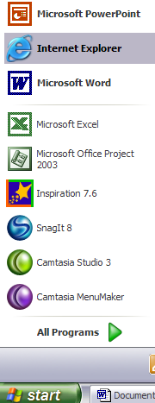

Step 1. Click Start

Step 2. Click Internet Explorer

I. Teacher Login

Step 3. Click in the address box

Step 4. Type: http://www.sasinschool.com

Step 5. Click the Keyboard: Enter key

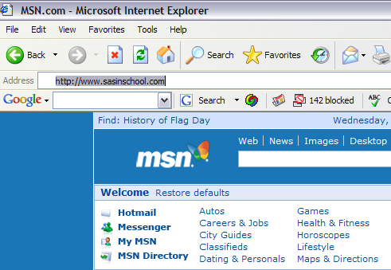

I. Teacher Login

Step 6. Click in the upper right corner ……….Subscriber Login

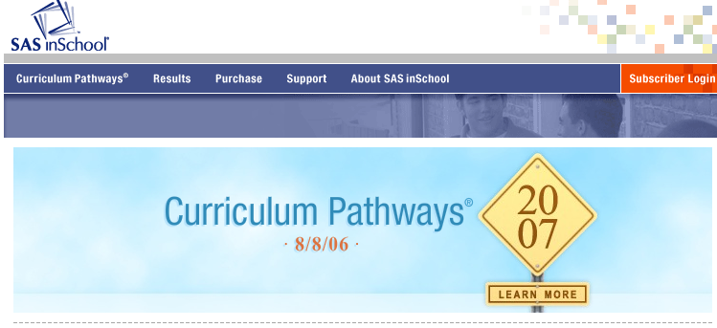

I. Teacher Login

Step 7. Look for User Name, and click in the white box.

Step 8. Type the following:…johnthoggardstaff

Step 9. In the Password box type:…..4305shipyard

Step 10. Click the GO Key.

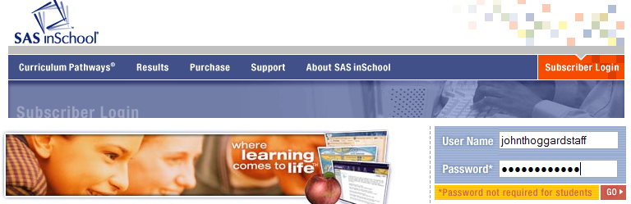

Great Job!! You are now logged into  home page.

- Select

- Subject Area
- Course
- Concept

II. Selecting Subject Area

- You are now logged into SAS in School Curriculum Pathways home page.

- Select one of the five Categories by clicking on the Subject Area
- Example: Click on Mathematics

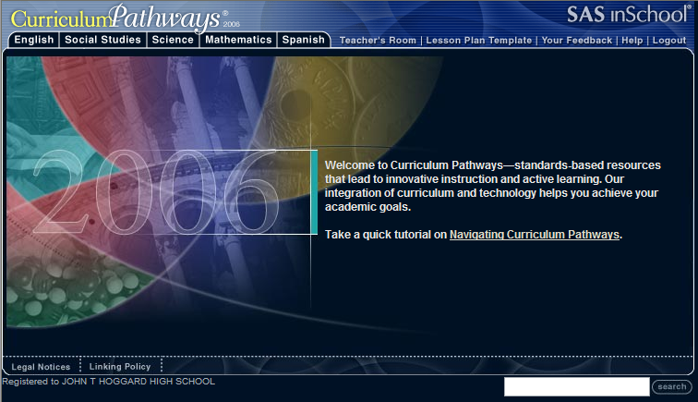

II. Selecting Course

- Each discipline is divided into a subject area,
relating to standard courses of study.

- Choose, as and example, Introductory Algebra as a course of study.
- Click Introductory Algebra.

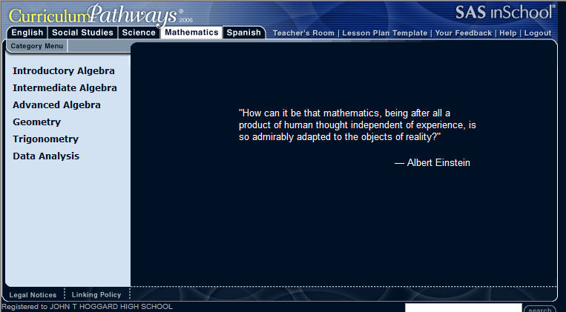

Super! Now go to the next page and read the Topics of Interest concepts.

II. Selecting Concept

- Each Course of study is divided into several Concept functions (Category Menu).

- Choose as an example, Polynomials & Factoring
- Click on the words Polynomials & Factoring

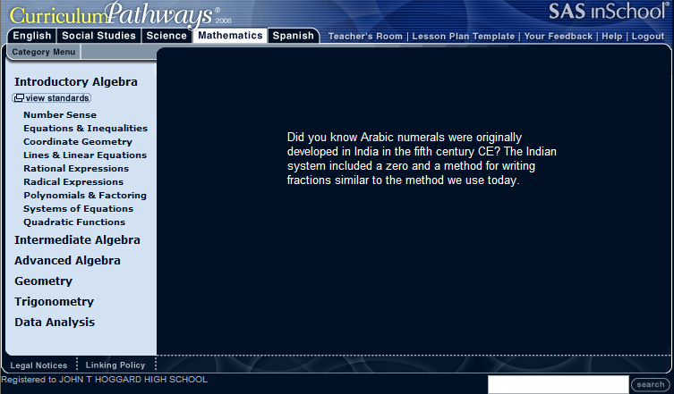

Excellent!...Now turn the page for an in-depth review of the Topics of Interest.

- Classify

- Available Resources
- Web Resources
- Classroom Activities
- Web Lessons
- Projects
- Launch

III. Classify

- Available Resources

III. Classify Available Resources

- When a Topic of Interest is chosen the At a Glance
list of resources appears:

  - Click Topic Overview.

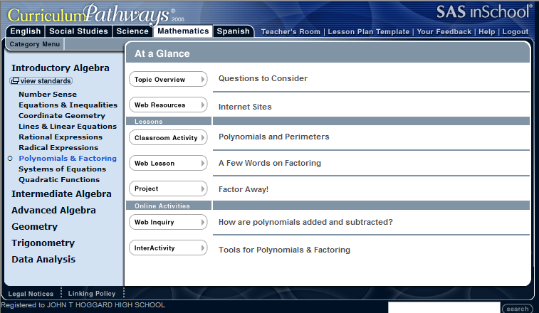

III. Classify Available Resources

- After clicking the Topic Overview
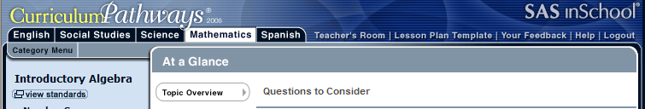

  - The adjacent message Questions to Consider displays:

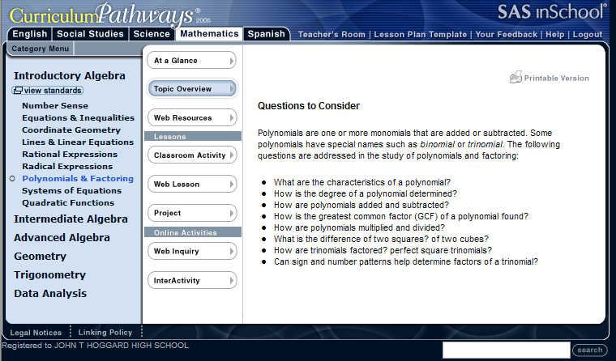

III. Classify

- Web Resources

III. Classify Web Resources

- When a Topic of Interest is chosen the At a Glance list of resources appears:

1. Click Web Resources.

III. Classify Web Resources

  - Click on each Internet Topic Site one at a time

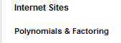
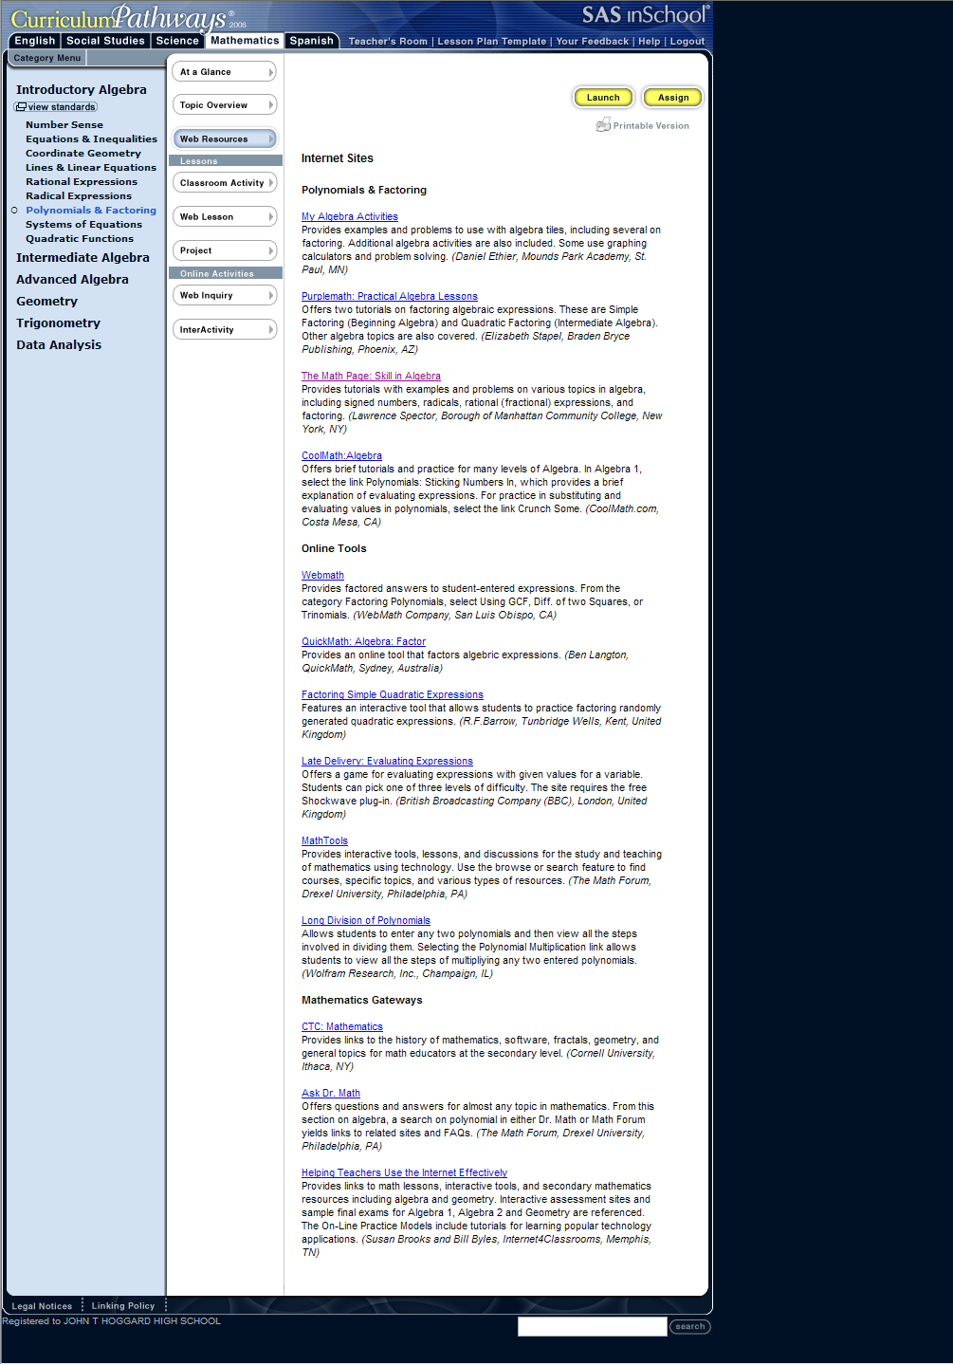

III. Classify Web Resources

  - Examples of Internet Sites for Polynomials and Factoring
  - Click on the Internet Site, My Algebra Activities

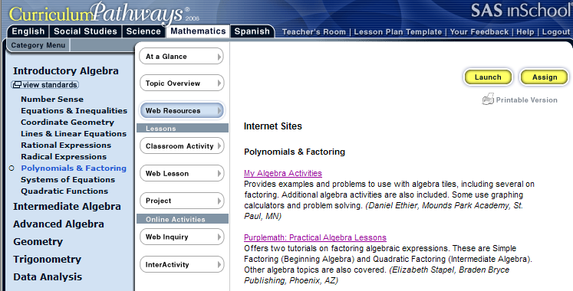

Go to the next page for more choices of
Internet Site - Polynomials and Factoring
My Algebra Activities ……………

III. Classify Web Resources

    - Examples of: My Algebra Activities
    - Scroll down for additional Resources

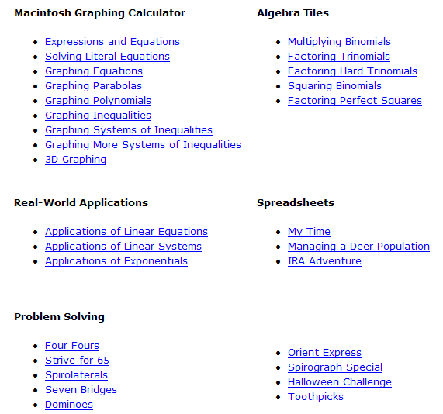

III. Classify Web Resources

  - Scroll to Online Tool of choice
  - Example: Click on Math Tools

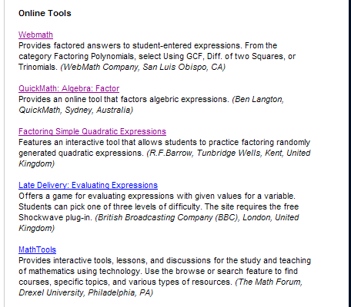

Go to the next page to read about
Internet Site - Polynomials and Factoring
Mathematic Gateways……………

III. Classify Web Resources

    - Examples of Math Tools
    - Set Browse information
    - Scroll and click Topic of Interest

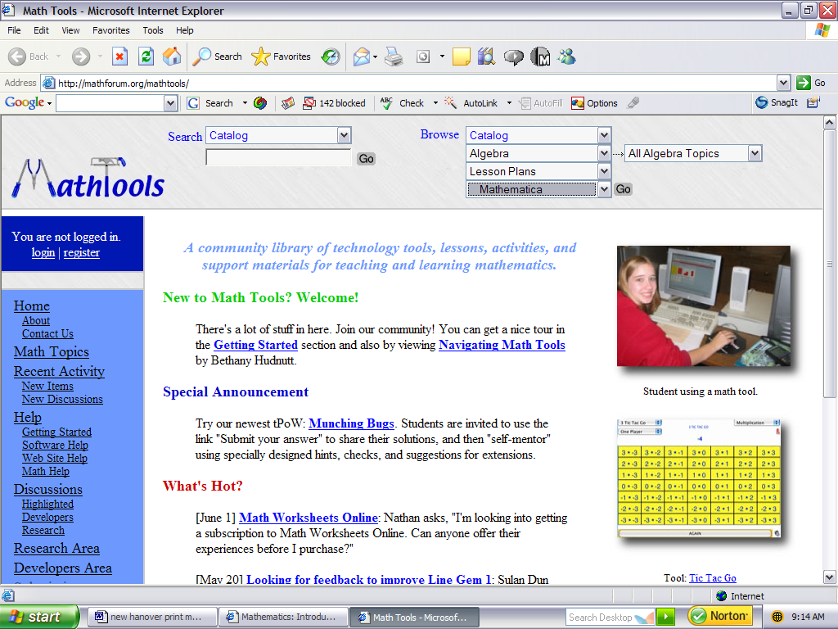

III. Classify Web Resources

  - Scroll to: Mathematics Gateways
  - Click on Helping Teachers Use the Internet Effectively

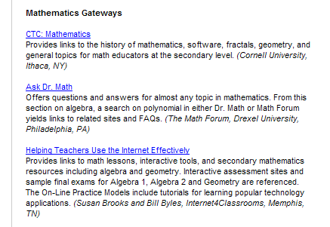

III. Classify Web Resources

9. When you click on Helping Teachers Use the Internet Effectively, the following options occur…………….

10. Click Links for K-12 Teachers

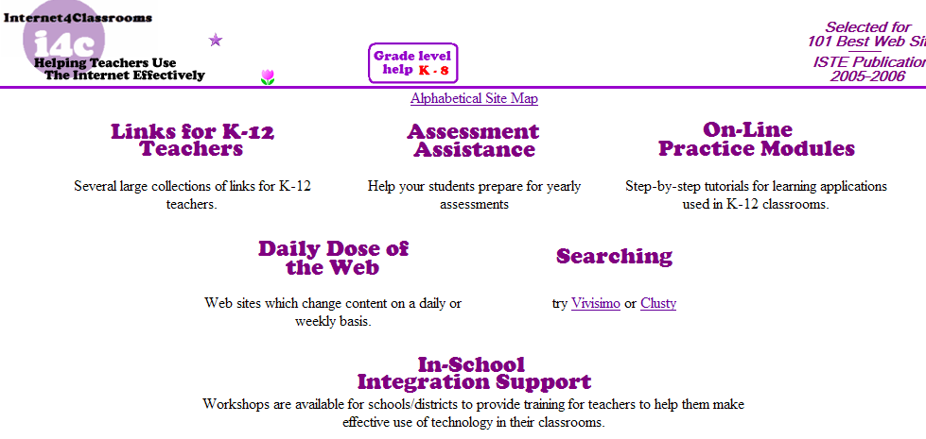

III. Classify Web Resources

11. When you click Links for K-12 Teachers the following screen appears
12. Scroll and click the Search window
13. Type in Polynomials
14. Click the Search key

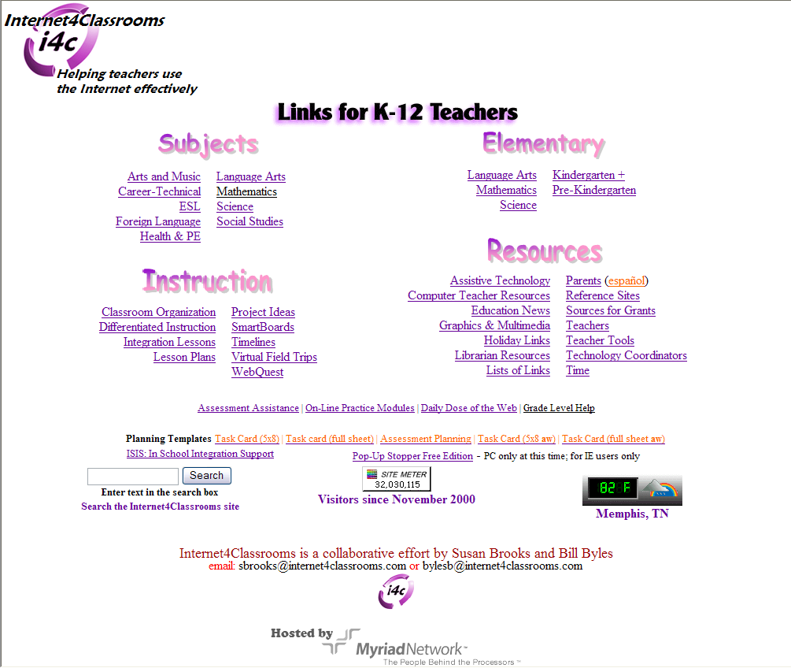

III. Classify

- Classroom Activities

III. Classify Classroom Activities

  - Scroll to Lessons for Polynomials and Perimeters
  - Click Classroom Activities
  - Read the Perimeters

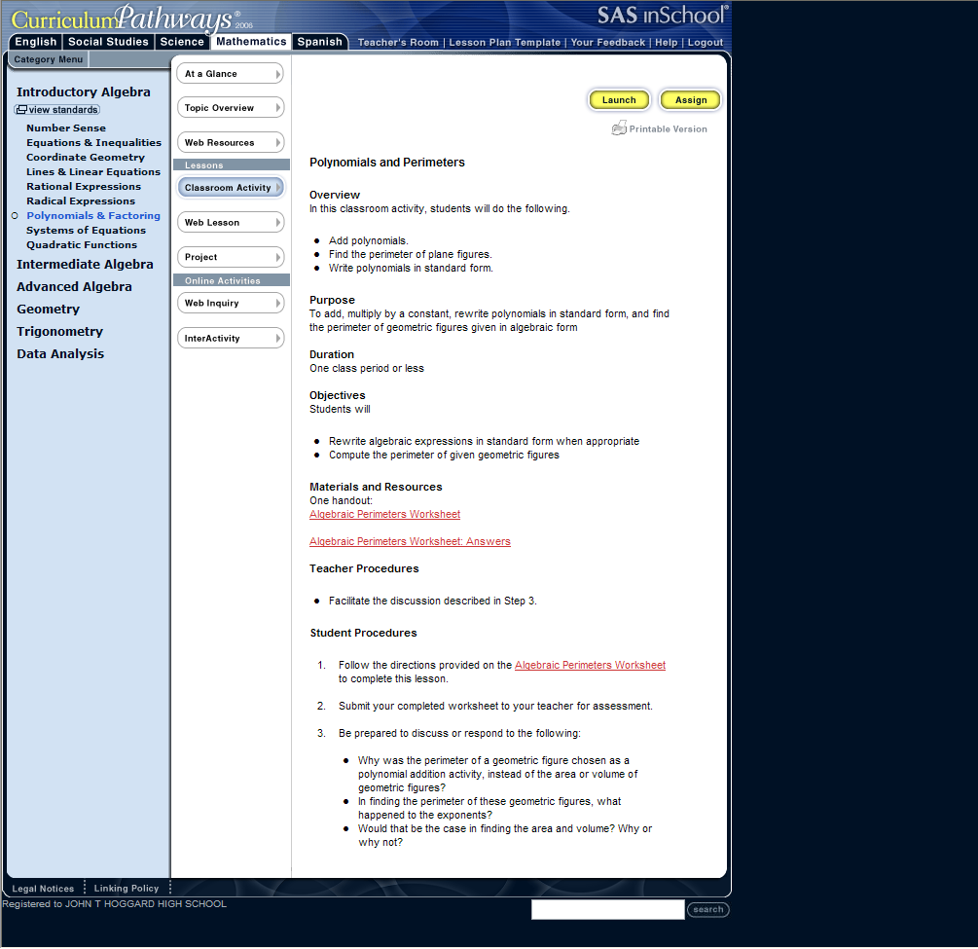
.

.

.

.

.

.

Go to next page to learn Internet connections
for Materials and Resources………
III. Classify Classroom Activities

    - Scroll to Materials and Resources
    - Click Algebraic Perimeters Worksheet
    - Click Internet Algebraic Perimeters Worksheet Answers

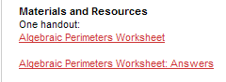

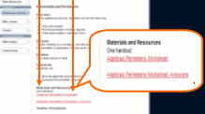

Continued from previous page…………….

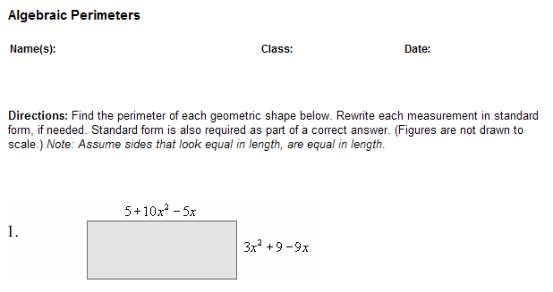

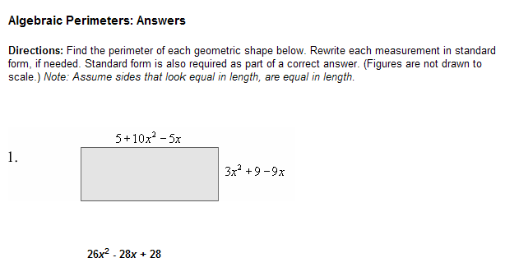

III. Classify Classroom Activities

- When you click on the Algebraic Perimeters Worksheet Internet connection, SAS requires a login for the screen below for students.

  - Type username
  - Do not type anything in the Password box
  - Click on the word GO

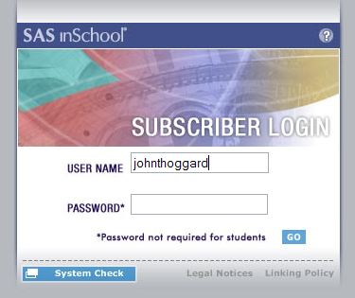

III. Classify

- Web Lessons

III. Classify Web Lessons

1. Click Web Lesson
2. Read:
3. Click Factoring Polynomials

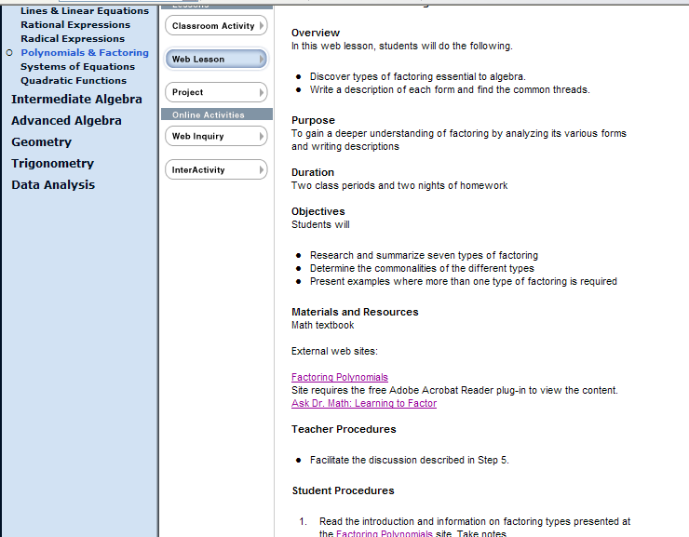
Overview

Purpose

Duration

Objectives

Materials and Resources

III. Classify Web Lessons

1. Following is the Factoring Polynomials screen
2. Scroll down the page to discover more options

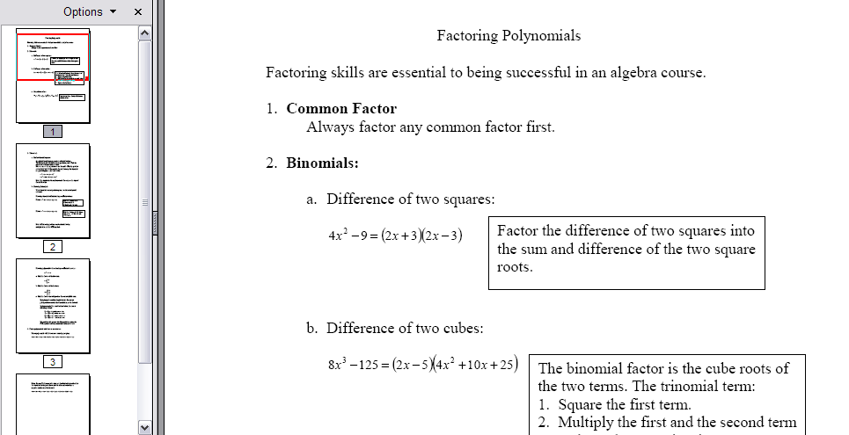

III. Classify Web Lessons

1. Click Ask Dr. Math: Learning to Factor

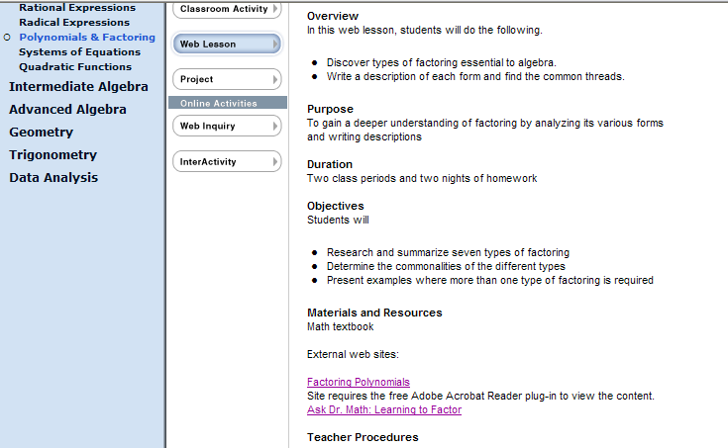

III. Classify Web Lessons

2. Ask Dr. Math: Learning to Factor screen
3. Click on Search Dr. Math
4. Type Polynomials
5. Click the Search button once

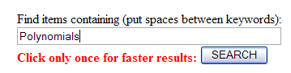
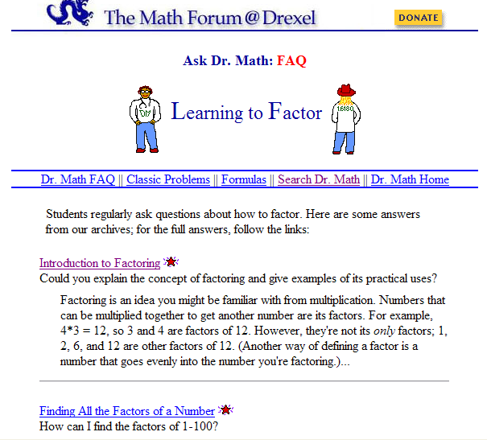

III. Classify

- Projects

III. Classify Projects

1. Click Project
2. Read

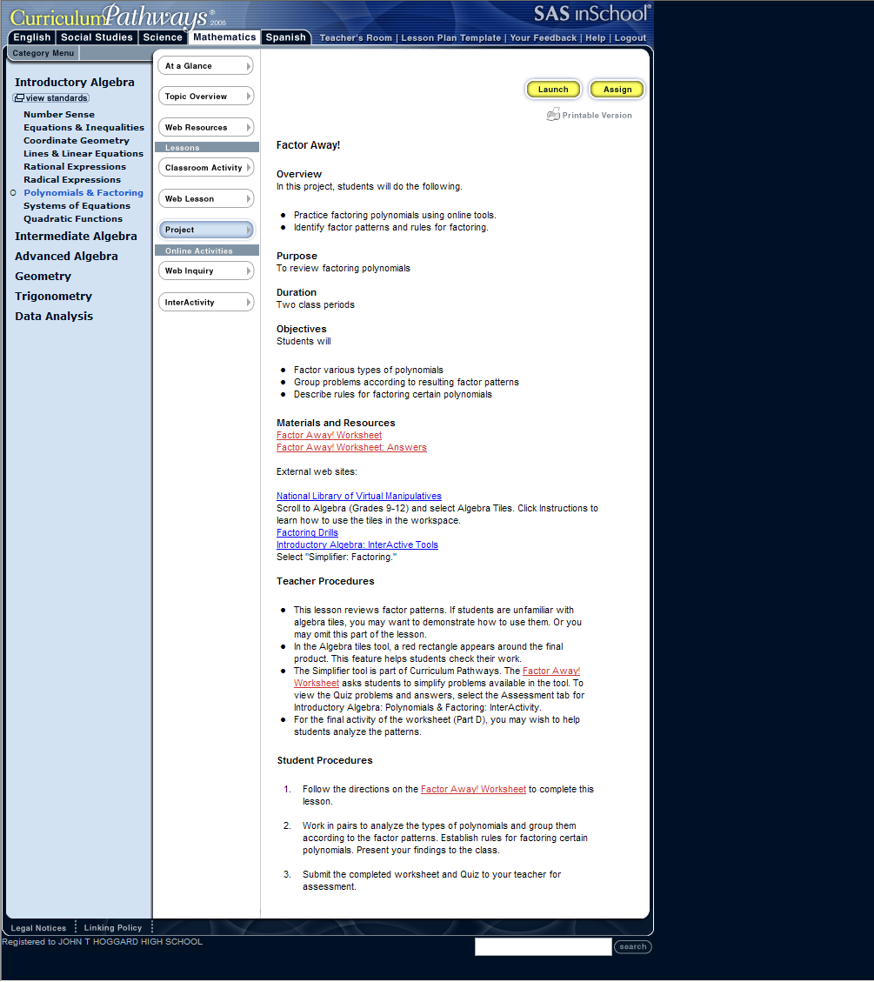
- Factor Away!
- Overview
- Purpose
- Duration
- Objectives
- Materials and Resources
- Teacher Procedures

III. Classify Projects

1. Scroll to Materials and Resources

2. Click Factor Away! Worksheet
3. Click Factor Away! Worksheet: Answers

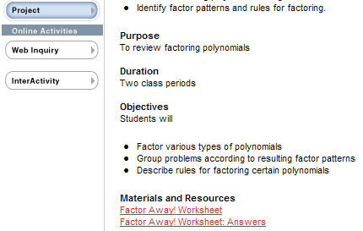

III. Classify Projects

4. Scroll to USER NAME:
5. Type username
6. Do not type anything in the PASSWORD box
7. Click GO

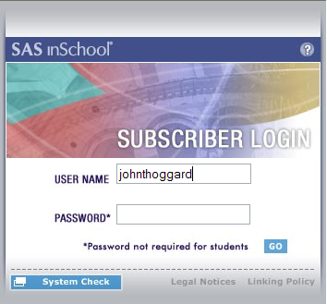

III. Classify Projects

1. The screen below opens
2. Click Mathematics

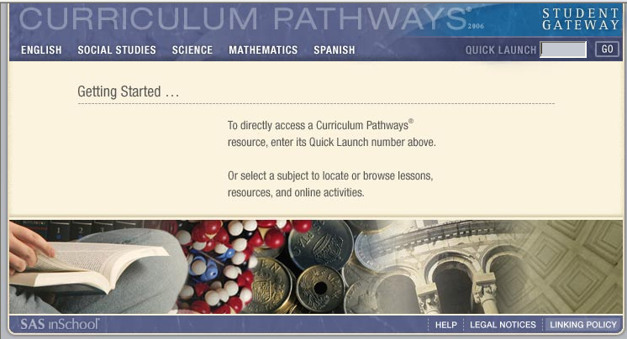

III. Classify Projects

1. A new menu appears
2. Click Introductory Algebra

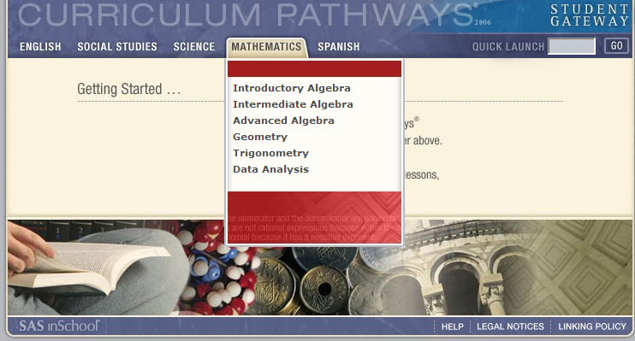

III. Classify Projects

1. A new menu appears
2. Click Polynomials & Factoring

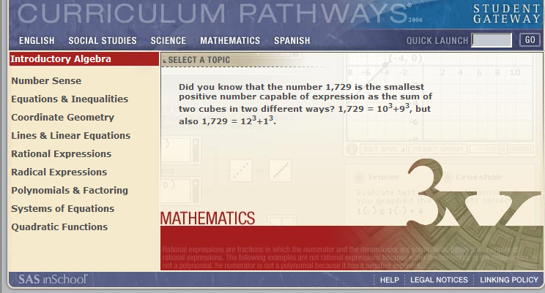

III. Classify

- Project Launch

III. Classify Project Launch

1. Important: A new LAUNCH menu appears
2. Type the number in the Launch box
3. Type 716 in the Launch box
4. Click GO

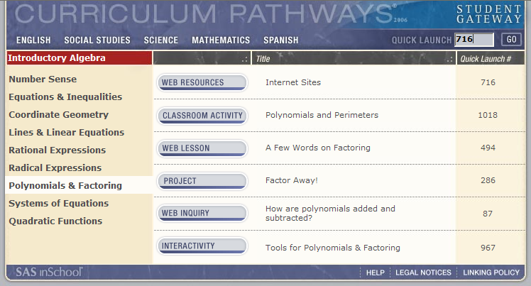

III. Classify Project Launch

1. A Web Resource page displayed from the LAUNCH menu
2. Notice the information and Internet links are the same as selecting from the previous site

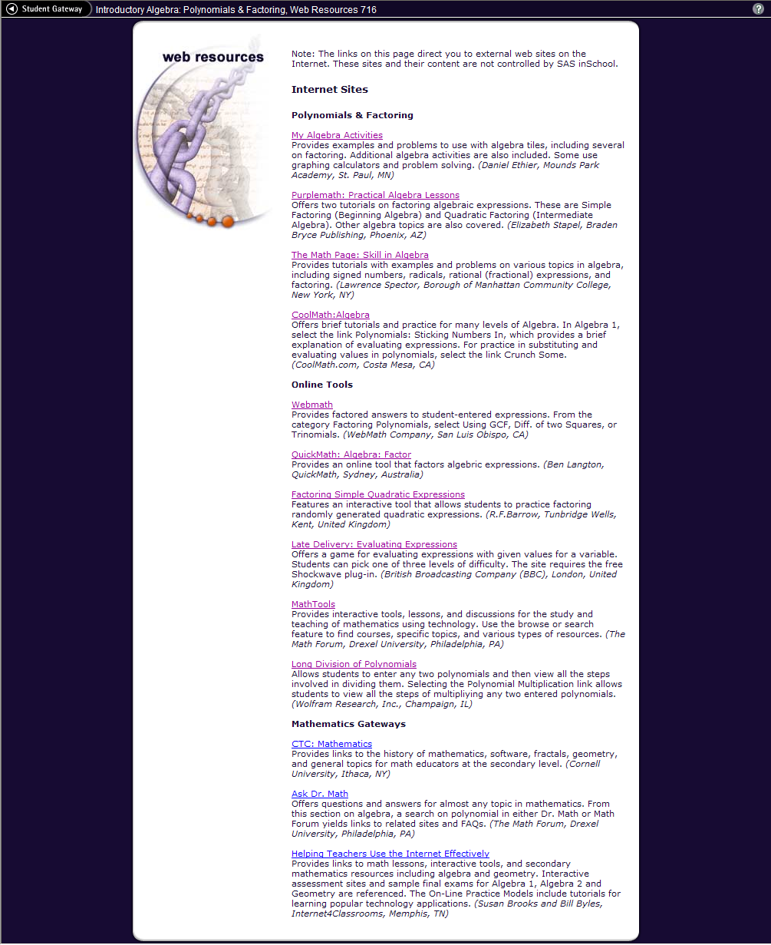

IV. Web

- Inquiry
- InterActivities
IV. Web Inquiry

IV. Web Inquiry

1. Look down the menu to WEB INQUIRY
2. Type the number 87 in the Launch box
3. Click GO

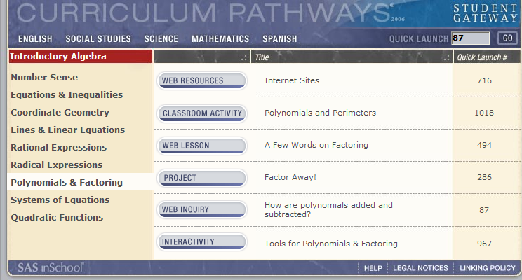

IV. Web Inquiry

1. Another way to review WEB INQUIRY
3. Click WEB INQUIRY

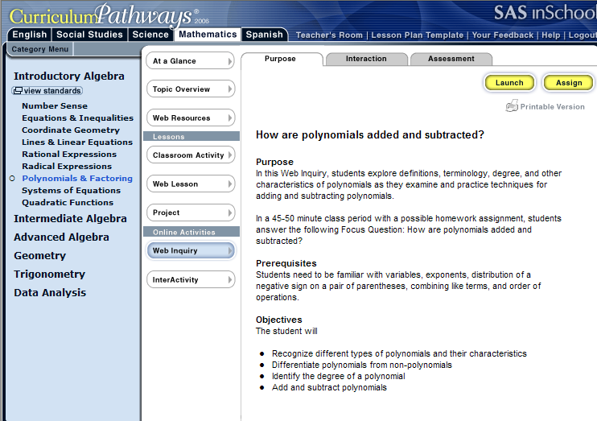

IV. Web Inquiry

1. Read the adjacent WEB INQUIRY screen

Purpose

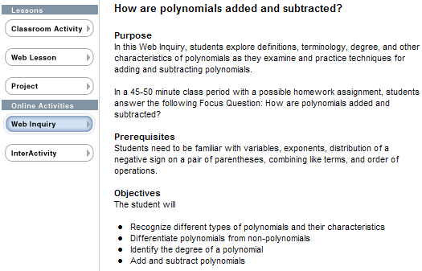
Prerequisites
Objectives

IV. Web Inquiry

1. More information for WEB INQUIRY
2. Click Interaction

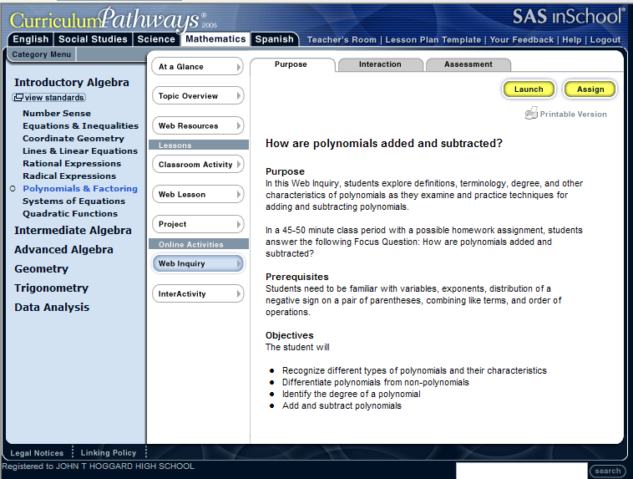

IV. Web Inquiry

1. The following Interaction page appears
2. Read the Interaction page

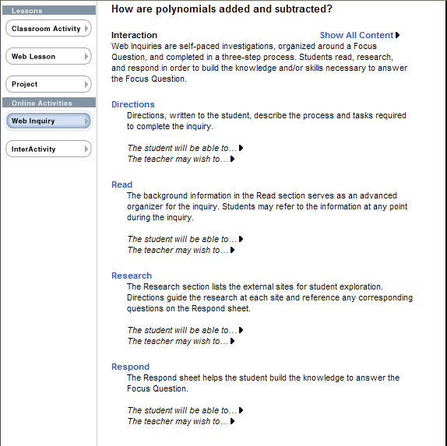
Directions
Read
Research
Respond

IV. Web Inquiry

1. Look at the top of the Interaction page
2. Click Show All Content

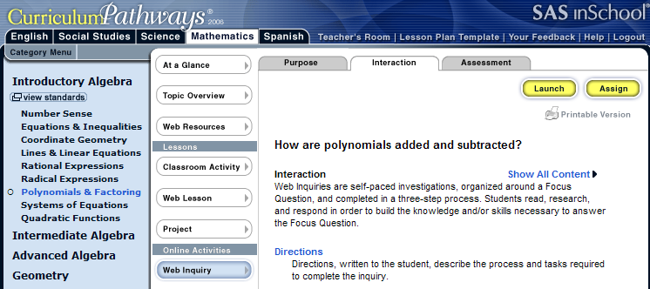
Show All Content

IV. Web Inquiry

1. Look the right of Show All Content and notice the ►
2. Click the ►

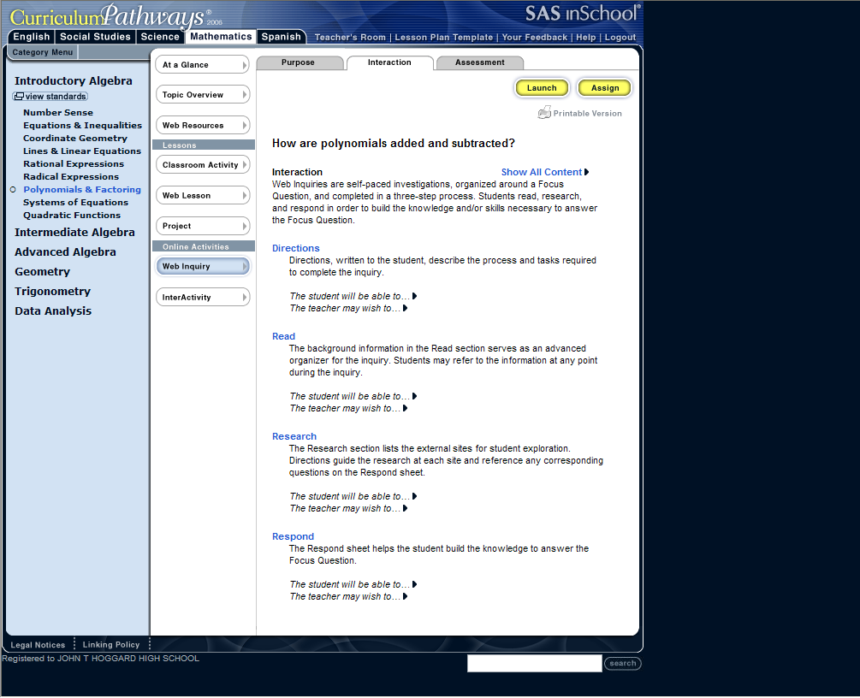

IV. Web Inquiry

1. OR - click any ▼in the text, additional information will display
2. Click the ▼, (notice the arrow turned down)
3. Now, try clicking on any ►and discover the change

Directions
Directions, written to the student, describe the process and tasks required to complete the inquiry.

The student will be able to…
- Quickly scan the assignment
- Print the Respond sheet, which guides the inquiry
The teacher may wish to…
- Organize class into pairs or small groups and require each student to complete a Respond sheet
- Make copies of the Respond sheet for the class. To do so, launch the Web Inquiry and under the Respond tab, select Printable version.

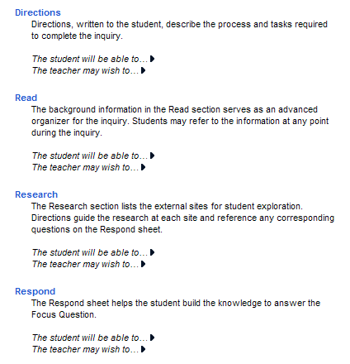

IV. Web Inquiry

- More information for WEB INQUIRY

1. Click the Assessment tab
2. Click the Web Inquiry Answer Sheet

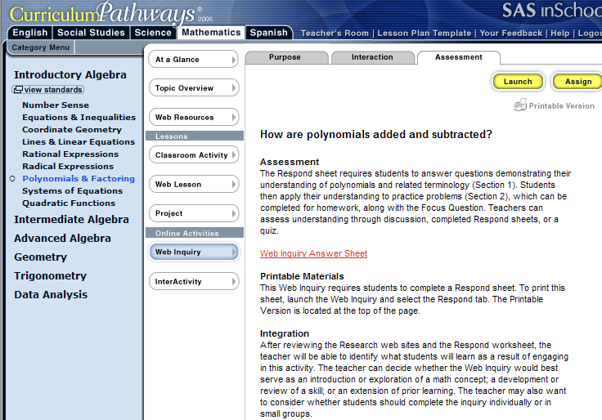

IV. Web Inquiry

1. Scroll to any feature of the Web Inquiry Answer Sheet

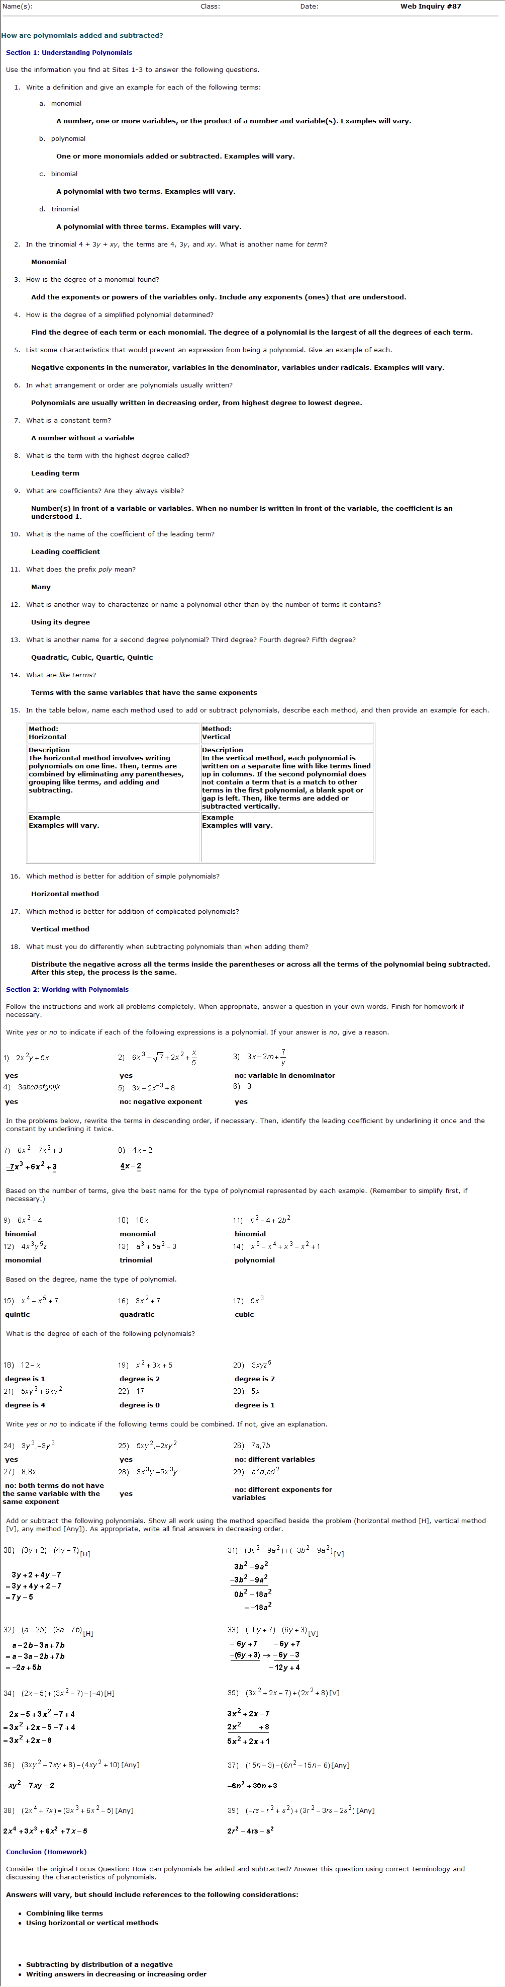
Section I: Understanding Polynomials
Section II: Working with Polynomials
Conclusion ( Homework )

IV. Web InterActivities

- InterActivities of the SAS environment depict simulations, multimedia resources and innovative tools to enhance teacher training and student enrichment.

IV. Web InterActivities

1. Return to original menu
2. Click InterActivities

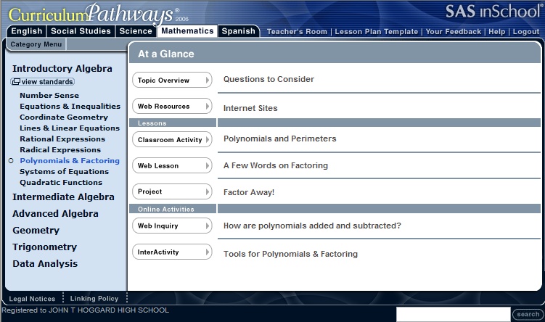

IV. Web InterActivities

1. Make certain the Purpose tab is active
2. Read Polynomials & Factoring: InterActive Tools

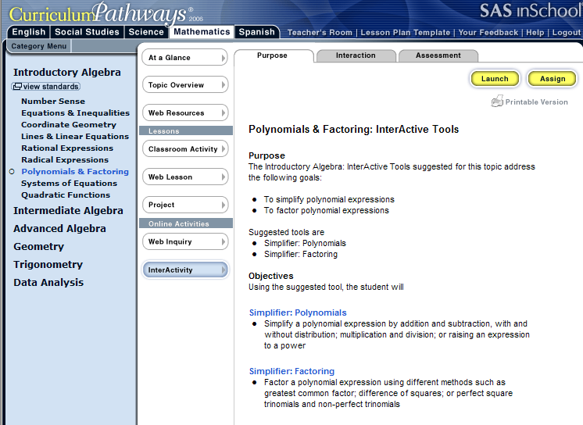

IV. Web InterActivities

1. Click the Interaction Tab
2. Read Polynomials & Factoring: InterActive Tools

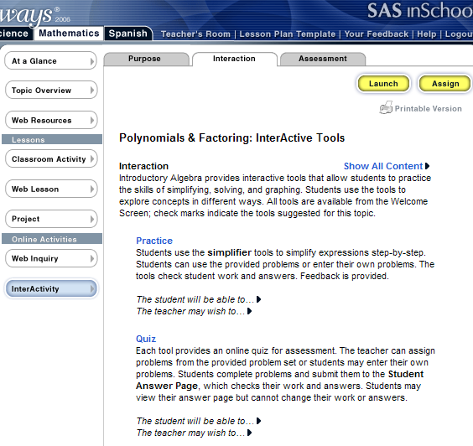

IV. Web InterActivities

3. Click Show All Content ► right side of page
4. Notice the ► points downward ▼ when clicked
5. Read the new information for Practice

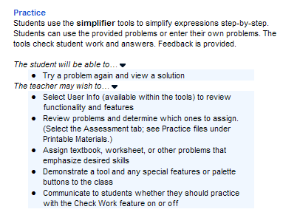

IV. Web InterActivities

6. Click Show All Content ►
7. Notice the ► points downward ▼ when clicked
8. Read the new information for Quiz

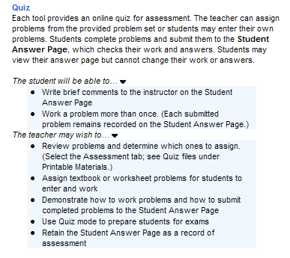

IV. Web InterActivities

1. Click the AssessmentTab
2. Scroll and read Polynomials & Factoring: InterActive Tools

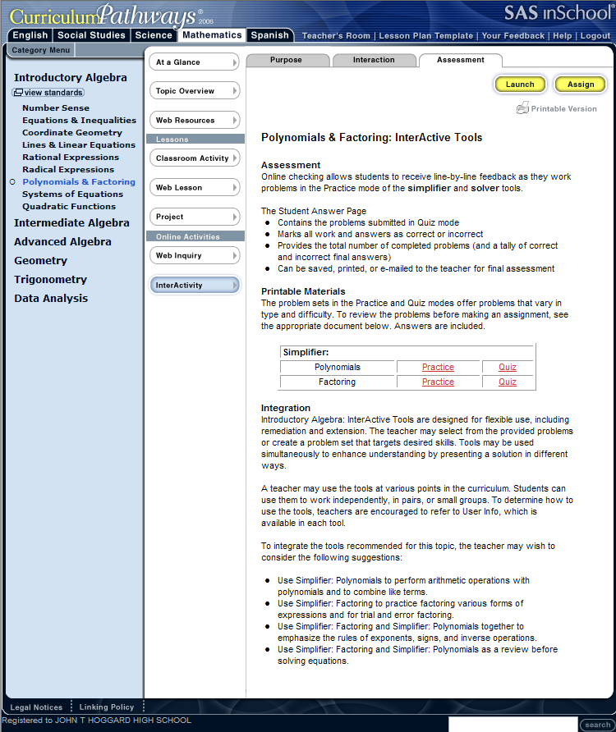

IV. Web InterActivities

1. Click Practice key (previous page example)
2. The Adobe® Reader 6.0 will appear
3. Allow Adobe® Reader 6.0 to finish
4. Practice examples with answers will appear

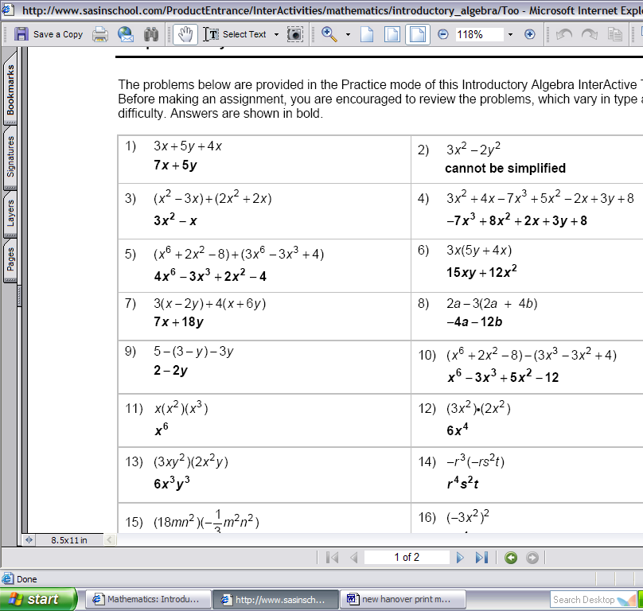

IV. Web InterActivities

5. There are 50 Polynomial examples with answers to choose
6. Go back and click the Quiz button
7. There are 20 chosen Simplifier: Polynomials for a Quiz

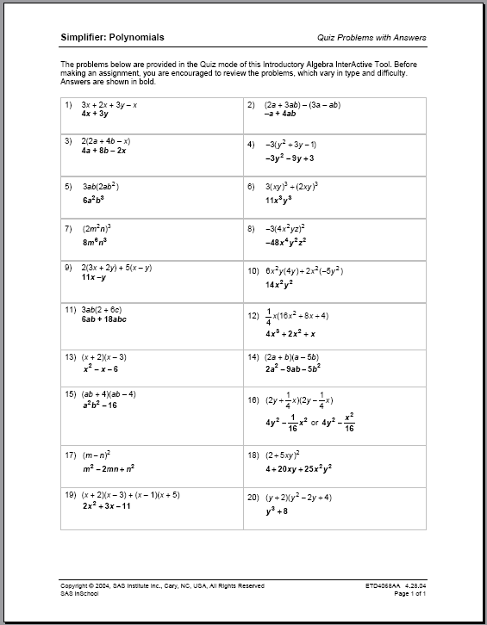

IV. Web InterActivities

1. Click the Factoring Practice key
2. The Adobe® Reader 6.0 may/may not appear
3. Allow Adobe® Reader 6.0 to finish
4. 50 Factoring Practice examples with answers

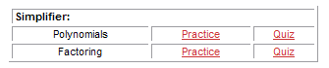

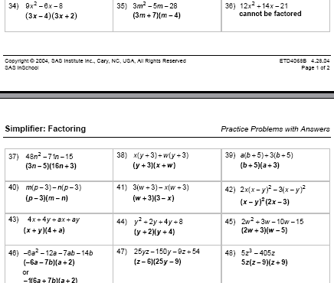

IV. Web InterActivities

4. Click the Factoring Quiz key
5. The Adobe® Reader 6.0 may/may not appear
6. Allow Adobe® Reader 6.0 to finish
7. 20 Factoring Quiz examples with answers

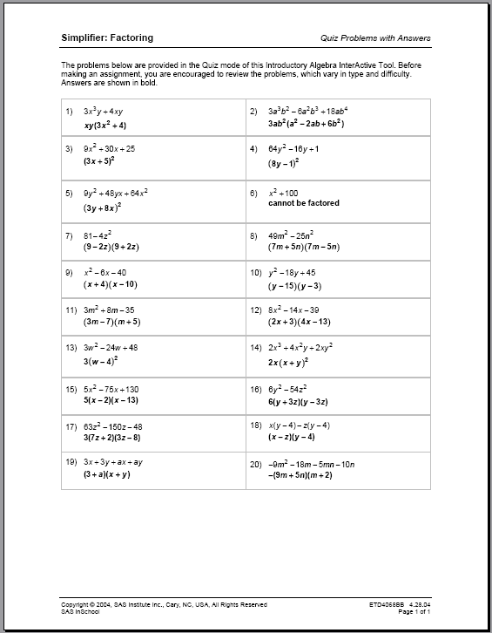

V. Launch Resource

V. Launch Resource

1. Choose a Category from the Menu
2. Click InterActivity
3. Click the Purpose tab
4. Click Launch

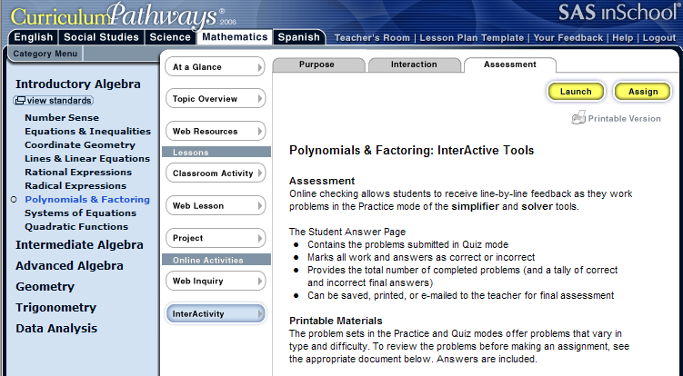

V. Launch Resource

1. When you click Launch the screen below will appear
2. Example: Click Simplifiers √ Polynomials

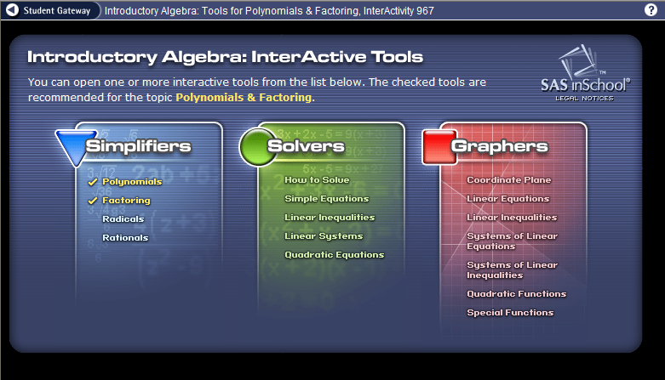

V. Launch Resource

1. The SASinSchool Checking Requirements is running
2. Allow Step 1: to run to 100%
3. Step 2: will automatically begin when Step: 1 is complete

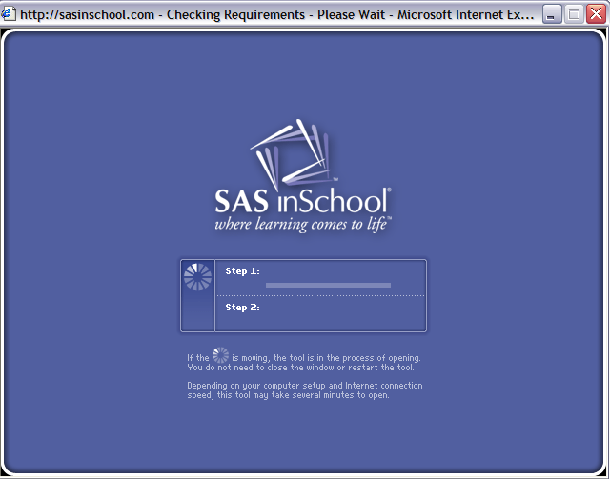

V. Launch Resource

1. Notice java is ready to run
2. Click Run (may/may not be required)

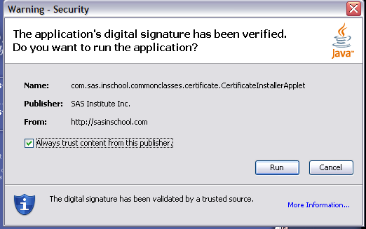

V. Launch Resource

1. Take time to review each button
2. The circles will lead you to the most frequently used
3. Step 1: click on the arrows to select a problem
4. Step 2: Click Start Work (the problem will copy to the work area)
6. Step 3: Use the characters to create your work and your answer
7. Step 4: Click Copy to Answer
8. Step 5: Check Answer

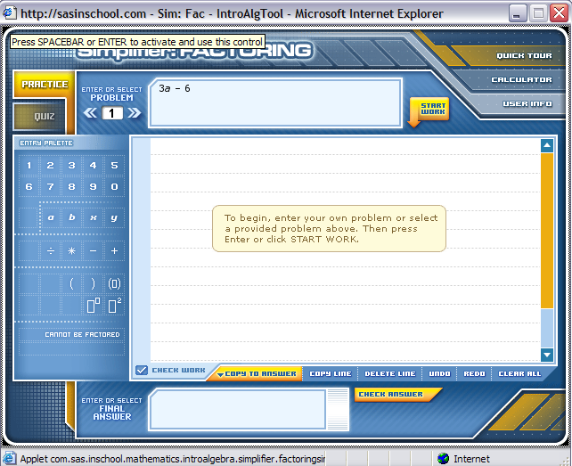
Step 5
Step 3
Step 4
Step 2
Step 1

V. Launch Resource

1. After you have finished steps 1-5
2. The following screen will appear

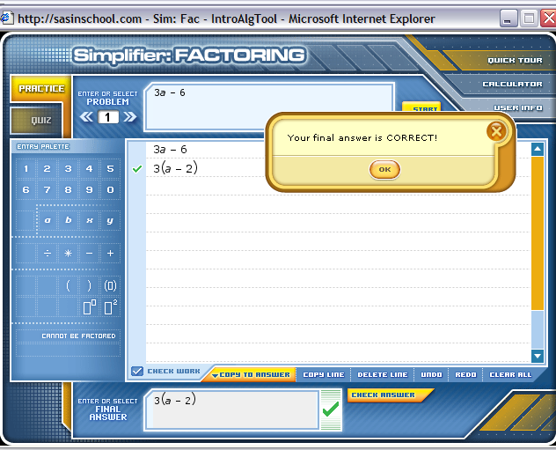

V. Launch Resource

1. Click

Step 1

V. Launch Resource

1. When you click the screen below will appear
2. Example: Click Solvers How to Solve

V. Launch Resource

1. Please click each button and become proficient using the screen
2. Click 

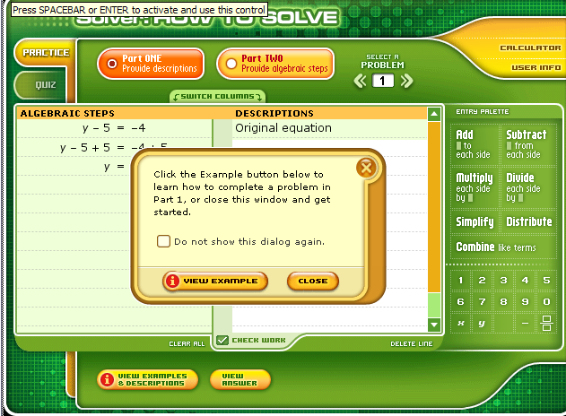

V. Launch Resource

1. When you clicked (previous page)
2. The following screen appears with exactly 

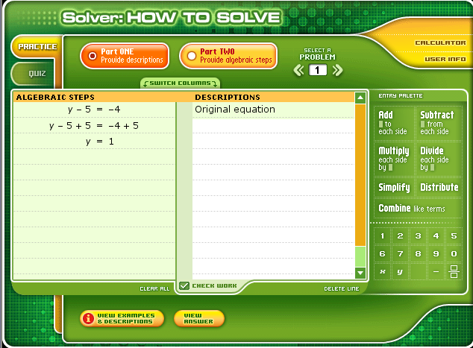

V. Launch Resource

1. Let’s try to solve a Quadratic Equation
2. Remember the steps:
3. Step 1: click on the arrows to select a problem
4. Step 2: Click Start Work (the problem will copy to the work area)
6. Step 3: Use the characters to create your work and your answer
7. Step 4: Click Copy to Answer
8. Step 5: Check Answer

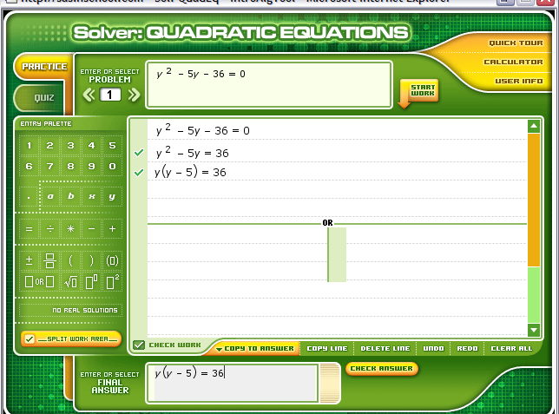
Step 1
Step 2
Step 3
Step 4
Step 5

You are absolutely right! Wasn’t that fun?
V. Launch Resource

Remembering!

1. Click

Step 1

2. When you clicked the screen below appears

3. Now click 

V. Launch Resource

1. Please click each button and become proficient using the screen
2. Everything you ever needed to know is a click away
3. Do not leave this page until you have clicked every button
4. Go back and click on more functions

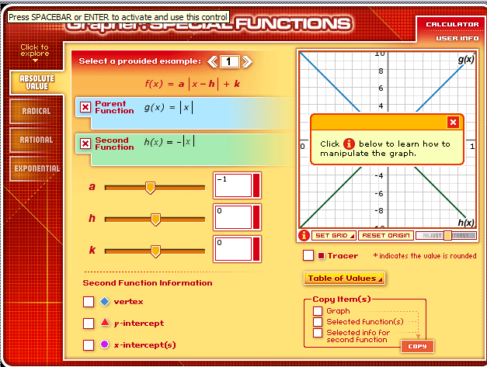

VI. Student Login

VI. Student Login

1. Click
2. Student login can occur at any time the procedure is the same

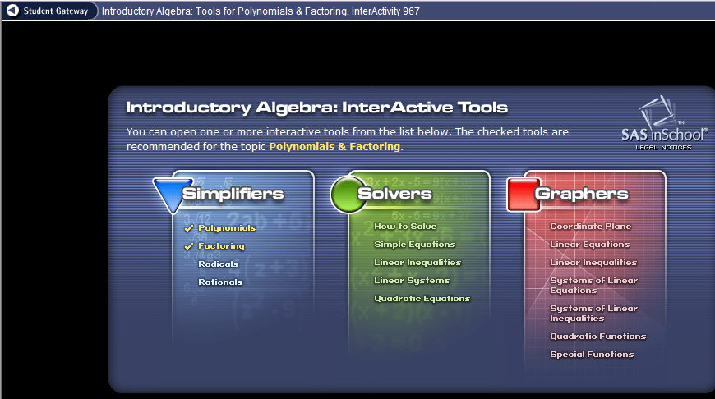

VI. Student Login

1. Clicking designed the following screen:
2. Student login can occur at any time the procedure is the same
3. Click in the USER NAME box
4. Type the username
5. Do not type a password
6. Click

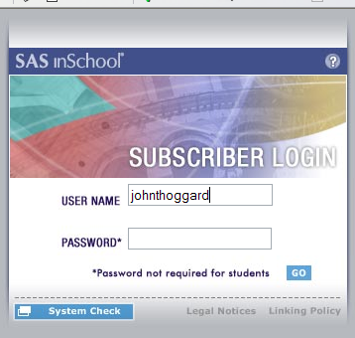

VI. Student Login

1. OR
2. Click Subscriber Login
3. Click in the USER NAME box
4. Type: username
5. Do not type a password
6. Click GO

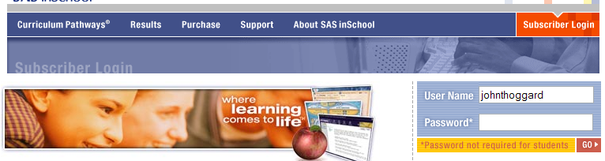

VI. Student Login

1. Click Mathematics
2. Choose Introductory Algebra as the subject matter

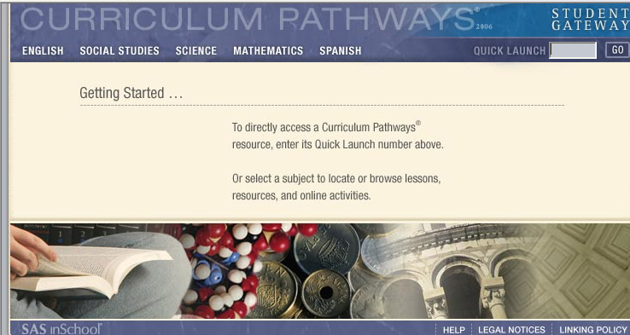

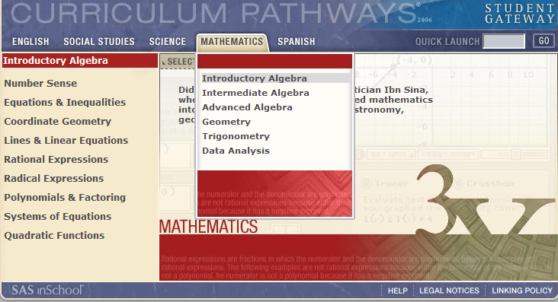

VI. Student Login

1. Click Polynomials & Factoring
2. Click INTREACIVITY or type the number 967 in QUICK LAUNCH

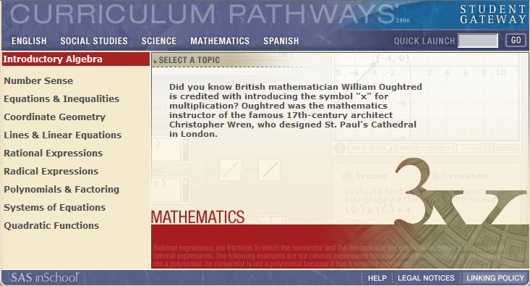

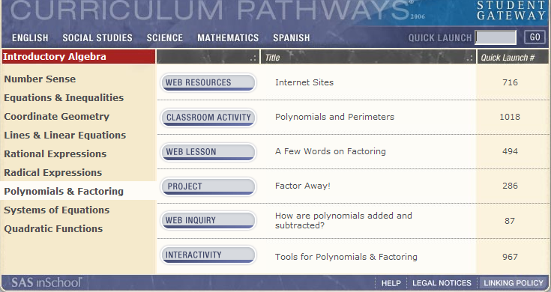

VI. Student Login

1. Guess what? You are back to the same screen as page 58
2. Simplifiers, Solvers, or Graphers
3. Choose any subject matter

Great Job! Student and Teacher studying is the same except for access to the answer sheets.

Look for the pictures and follow the arrows.

VII. Assign Resources for Teachers
VII. Assign Resources for Teachers

1. REMEMBERING
2. Repeat pages 3 through 6
3. Click Teacher’s Room

VII. Assign Resources for Teachers

1. There are three topics: Web Resources, Checklists, Tutorials
2. Under each topic is a list of Internet sites
3. Example: Click online quizmakers

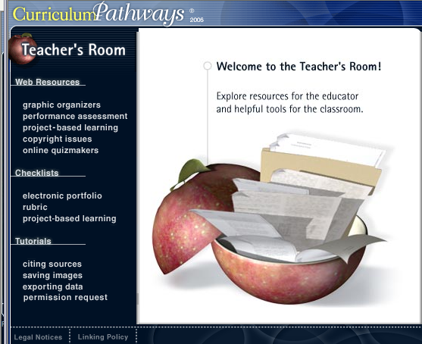

VII. Assign Resources for Teachers

1. There are two Quiz Generators
2. Three Puzzle Makers
3. Two Gateways
4. Click any Internet quizmaker

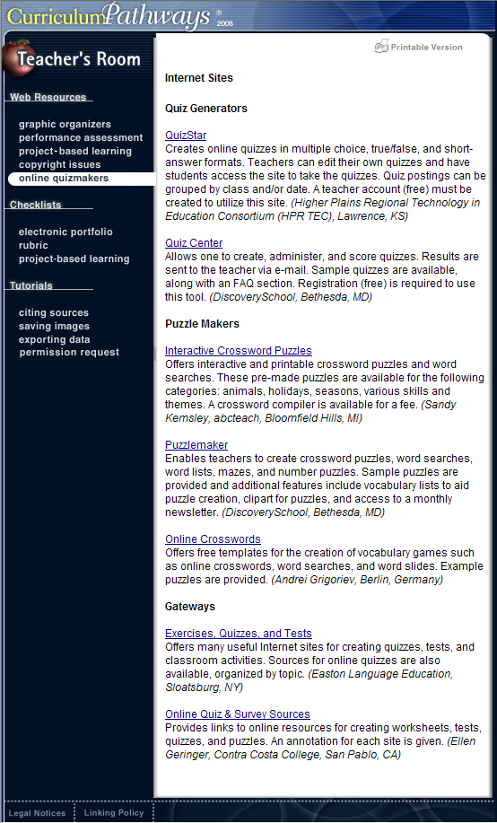

VII. Assign Resources for Teachers

1. Click exporting data

VII. Assign Resources for Teachers

2. Scroll and choose a topic

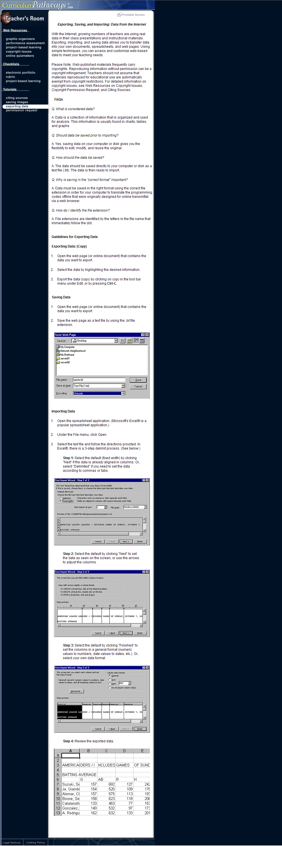
FAQ’s
Guidelines for Exporting Data
Saving Data
Importing Data

VII. Assign Resources for Teachers

1. Click Lesson Plan Template

Turn the page and review a Lesson Plan Template

VII. Assign Resources for Teachers

Internet Lesson Plan Template

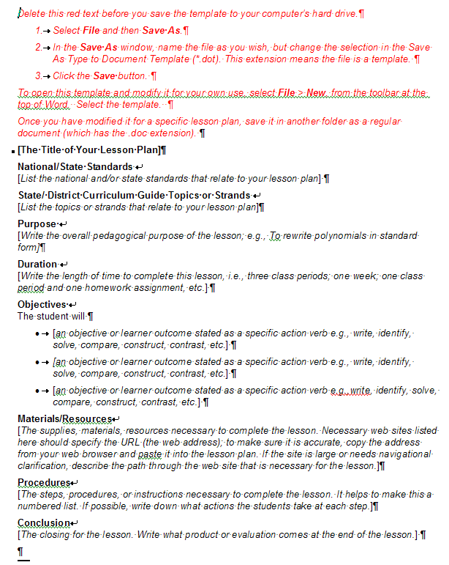
VII. Assign Resources for Teachers

1. Click Your Feedback

Turn the page and review a Feedback form…..

VII. Assign Resources for Teachers

1. Click Your Feedback

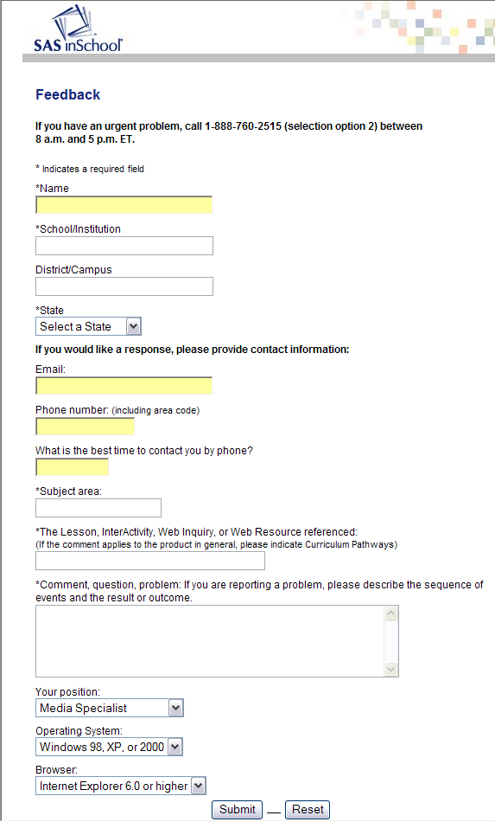
VII. Assign Resources for Teachers

- Click Help

Turn the page and review the Help page…..

VII. Assign Resources for Teachers

2. Click Help Topics
3. Notice there are six (6) pages of Help Topics

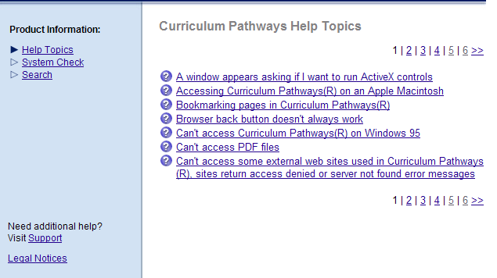

VII. Assign Resources for Teachers

4. Click System Check

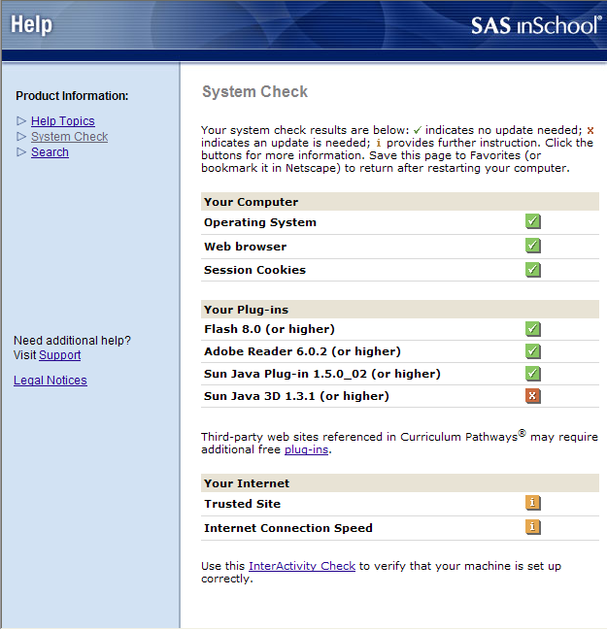

VII. Assign Resources for Teachers

- Click Legal Notices

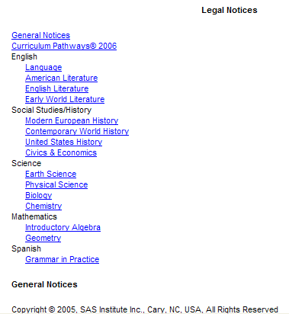

Click on any Internet link for
Legal Notices.
The End.
I trust you find the manual helpful
as well as enjoyable.

